**THE 2019 COMPARATIVE SNOW CRAB SURVEY VESSEL EXPERIMENT IN THE SOUTHERN GULF OF SAINT LAWRENCE**

**by Tobie Surette**

**INTRODUCTION**

The ability to meaningfully compare abundance levels between different time periods or regions requires that the catch observations on which they are based be suitably standardized. Standardization in this context refers to the control or accounting of nuisance factors through experimental protocols or analytical methods, with the goal of stabilizing their effect on variables of interest. Failure to standardize catches result in abundance indices with time or spatially varying biases that no longer reflect true changes in population abundance.

The southern Gulf of Saint Lawrence (sGSL) snow crab (*Chionoecetes opilio*) trawl survey currently standardizes its catches using estimates of swept area for each tow. These are calculated from acoustic monitoring probes that measure the width of the trawl, a vessel GPS that provides a proxy for trawl speed, and depth or tilt angle probes that provide information on trawl touchdown times.

Other than swept area, other factors that affect catches are the catchability of animals encountering the trawl, i.e. the probability of an animal laying in the path of the trawl entering it, and the selectivity of the trawl, i.e. the probability of an animal being retained within the trawl once it has entered it. In turn, these factors depend on vessel speed, sediment type, accumulation of debris in the trawl, sea conditions, etc.

In 2019, the Avalon Voyager II replaced the Jean Mathieu as the new snow crab survey vessel. To determine whether there are systematic differences in catchability for snow crab between the two vessels, a side-by-side comparative fishing experiment was performed at the end of the survey. Where differences occur, we will attempt to identify their source using a suite of data probes that were deployed for this purpose during fishing.

**METHODOLOGY**

The final set of 40 sampling stations of the regular 2019 snow crab survey were selected for the side-by-side comparative fishing experiment off the coast of western Cape-Breton (Figure 1). These stations were selected as a function of survey timing, budget considerations, spatial contiguity and suitability of the sea bottom to trawling. The new survey vessel, the CFV Avalon Voyager II, fished alongside the CFV Jean Mathieu, the previous survey vessel used from 2013-2018. Both vessels used identical fishing gear, a Bigouden Nephrops trawl (Conan et al. 1994) and applied the same fishing protocol. The experiment took place from September 19th to September 25th, 2019, based out of Cheticamp, Cape Breton. Survey vessels are 65 feet in length and are based out of the Magdalen Islands. The raw tonnage is 99 tonnes for the steel-hulled Jean Mathieu and 138 tonnes for the fiberglass-hulled Avalon Voyager II. The Avalon has a more powerful 850-horsepower engine compared to the 720 horsepower engine of the Jean Mathieu (Figure 2).

**TRAWLING SEQUENCE OF EVENTS AND PROTOCOL**

For the analysis, special focus will be made on possible biases in the estimation of swept area. While it was hoped that video footage would shed some light as to the catchability of organisms encountering the trawl, we were unable to obtain suitable video footage during the study. While selectivity of organisms within the trawl may be affected by the accumulation of debris in snow crab survey tows, we will assume it to be similar between the two trawls at a given site, given that catches and sediment composition are very similar on the short spatial scales considered.

We first present the sequence of phases and events of the trawling process during snow crab tows. During the first phase, the trawl is cast and then descends through the water column, with the vessel moving at moderate speed so as to expand the trawl net and separate the trawl doors. The winch is lets out a pre-determined length of warp cable, rounded to the nearest 25 fathoms which is closest to a target 3:1 ratio with the water depth at the fishing location. For depths exceeding 175 fathoms, a maximum warp length of 525-550 fathoms is used. The winches are then locked and the survey vessel slows near target trawling speed of 2 knots. The trawl continues to descend through the water column, generally approaching its maximum vertical speed in the minute prior to bottom contact. Bottom contact generally occurs after winches are locked, but this is not always the case. The trawl experiences two strong pulses of vertical deceleration: the first is when one or both trawl doors first touch down, followed by a second, stronger deceleration coincident with the contact of the footrope on the sea bottom. The trawl headline settles a further 1-1.5 meters as the doors and wings stabilize to their full, expanded width during the first 20-30 seconds of trawling. At the five-minute mark, a stop signal is given for the vessel to slow down and the trawl winches to be activated. The trawl remains on the bottom for a short time afterwards before lifting off the bottom. Tows with major net damage on either survey vessel were rejected and moved to an alternate sampling station.

Based on the sequence of events described above, the trawling process is made up of the following events and phases:

* **Descent phase**: The period during which the trawl descends the water column.
* **Touchdown time**: The time at which the trawl initially touches the sea bottom. This is assumed to be the time at which active trawling begins. While the trawl doors are the first part of the trawl to touch the bottom, the operational definition used for our purposes is here defined as the first significant contact of the trawl footrope and the sea bottom.
* **Trawl stop time**: The time at which an on-board stop signal is given by the survey chief. The trawl winches are activated and the survey vessel decelerates. This is the time at which active trawling is ends.
* **Active trawling phase**: The period between the touchdown time and the trawl stop time. During this phase, the survey vessel pulls the trawl along near for a target 5 minutes. target speed and actively pulling the trawl along the sea bottom.
* **Liftoff time**: The time at which where the footrope of the trawl leaves the sea floor during winching of the trawl.
* **Passive trawling phase**: The period between the trawl end time and the trawl liftoff time. During this phase, forward motion of the vessel or other vessel manoeuvres, winching of the tow cables, sloping bottom gradients may lead to additional movement of the trawl which is not presently accounted for in the swept area estimate.
* **Bottom phase**: The total period represented by the active and passive trawling phases.
* **Ascent phase**: The period during which the trawl footrope leaves the bottom and the trawl net is ascends through the water column and approaches the survey vessel.
* **Winch activation**: Winches are activated and begin winding the warp cable just after the stop signal is given.
* **Door touchdown**: The time at which the trawl doors make contact with the sea bottom in the period before the trawl footrope touches down.
* **Door liftoff**: The time at which the trawl doors leave the sea floors and begin ascending through the water column. The timing of this event occurs prior to and may sometimes be coincident with the footrope liftoff.

A schematic showing the sequencing of these phases and events is shown in **Figure 5**.

**DATA**

The following is a list of data probes and devices used to gather environmental data and monitor trawling during the comparative experiment (Figure 3).

* ***eSonar*** : Acoustic trawl measurement system used since 2013. Provides measurement of trawl headline depth, headline height from the bottom, trawl wing spread separation. Sapling rate 4-7 seconds. However, data is often noisy or missing due to weak signals, mis-orientation of probes, etc…
* **Star Oddi** : Attached to the trawl head line since 2013, these probes provide high resolution temperature and pressure readings. In addition, a tilt-mechanism, attached to directly on the trawl footrope, detetermines the tilt angles using an internal accelerometer. In addition a Magnetic Star Oddi Tilt-TD was used which includes a digital compass in addition to its normal functions. Sampling rate is 1 per second.
* **Nortek Aquadopp 300 m** :In addition to its regular compliment of probes and recorders, a single-point Doppler flowmeter, the Nortek Aquadopp 300 m, was used in an effort to gather information regarding trawl movements during the passive trawling phase, prior to the trawl lifting off the bottom. This device contains a digital magnetic compass which allows for conversion of its three dimensional water flow rate measurements into real-world coordinates, relative to the magnetic North pole. The flowmeter was suspended just below the trawl headline using a stainless steel bracket (Figure 4).
* **CTD :** A Conductivity-Temperature-Depth probe was used on a portion of the Avalon’s comparative tows. The cable attached to this device snapped and the probe was lost mid-experiment.
* **GoPro 7** : Also affixed to this bracket was a GoPro 7 with two submersible lights attached on either side (Figure 4).

The above devices, notably the eSonar, Star Oddi and flowmeter provided data on the following variables, which were used for inferring various parameters related to the environment as well as trawling:

* **Pressure/Depth** : For some purposes, pressure can be linearly rescaled to some estimate of water depth in order to get absolute measures of vertical movement. These are useful to determine vertical rates of descend or ascent, and determination of touchdown and liftoff times of the trawl.
* **Temperature** : The headline and footrope both measure ambient water temperature. However, water temperatures from the footrope probe are less suitable for inferring bottom water temperatures since its protective casing slows its thermal equilibration during in tows with short bottom times. Thus, reported water temperatures are from the headline Star Oddi probe after thermal equilibration.
* **Tilt** **angle**: One of the angles returned by the tilt probe is the angle between its central axis and the plane perpendicular to the Earth’s gravitational force. The touchdown and liftoff times of the trawl can be determined with a high degree of accuracy using these data.
* **Heading** : The magnetic compass inside the tilt probe returns the orientation of the probe relative to the Earth’s magnetic North Pole. This allows for tracking of the heading of the trawl during various phases of trawling, as the tilt probe is generally perpendicular to the middle of the trawl footrope.
* **Water flow rates** : A Doppler single-point flowmeter was attached and yielded usable water current data in 17 tows during the comparative survey. The probe was attached underneath the headline. The total current flow.
* **Trawl wing spread :** The width of the trawl is monitored by a pair of eSonar probes on the wings on either side of the trawl.These values, along with trawl speed are a requirement for estimating trawl swept area.
* **Trawl height :** The height of the trawl relative to the bottom is monitored by an eSonar probe attached to the headline. Along with eSonar depth observations, it can be used for real-time assessment of the trawl touchdown time.

All snow crab were measured for carapace width (CW) and shell condition as well as the pattern of missing and regenerating walking legs and chelipeds. Males larger than 40 mm CW were measured for chela height to morphometrically identify sexual maturity. Crab measurements were made using a Vernier digital caliper recording to a precision of 0.01mm. Qualitative assessments of female egg colour and percentage of egg content were recorded for mature females, as well as gonad colour for immature females.

Species other than snow crab were identified to the species when feasible, or to higher taxa otherwise. These were weighed using a Ryco #820A weight scale on the Jean Mathieu and a Marel M1100 onboard the Avalon Voyager II. Where practical, species were also counted.

In addition to regular fish sampling, all Atlantic cod (*Gadus morhua*), American plaice (*Hippoglossoides platessoides*), witch flounder (*Glyptocephalus cynoglossus*) and yellowtail flounder (*Limanda ferruginea*) were subsampled for fish length. For 13 of the 40 stations on board the Jean Mathieu, all fish species were measured for length as part of a regular groundfish sampling program. Fish lengths were recorded using a Scielex electronic measuring board to the nearest millimeter. In cases of device malfunction, fish lengths were made by hand and recorded to the nearest centimeter.

**SWEPT AREA ESTIMATION**

Swept area is the only variable currently used to standardize snow crab survey catches. Its calculation requires knowledge about the width and speed of the trawl as it sweeps over the sea floor as well as a time interval which defines when trawling begins and ends. However, there are a number of issues with the estimation of swept area.

The first issue relates to the availability of reliable trawl width data, as measured by a pair of eSonar acoustic probes attached on either side of the trawl. These wing spread observations are subject to varying degrees of missing data and noise contamination. Notably, issues with the eSonar system aboard the Jean Mathieu led to a total of 13 of tows with seemingly no wing spread data available. Additionally, there were some tows with few reliable data observations. Rather fortuitously, the Avalon Voyager II was equipped with two rather than a single sonar receiver, which were oriented in different directions. This addition was brought about a remedy to the weak acoustic signals which were problematic on the Jean Mathieu in previous years. This lead to many occasions where, due to the two vessels’ proximity, a portion of the Jean Mathieu eSonar probe signals were picked up and recorded in the Avalon’s eSonar feed. Fortunately, the signals from each vessel generally favoured one or the other transducer and so could be separated for the analysis.

Despite this, we are still left to deal with a significant proportion of missing and noisy data. Rather than remove stations with weak of missing wing spread observations from the analysis, a hierarchical Bayesian model was developed to filter out noisy observations and interpolate missing wing spread data. In this way, time series of wing spread values were modelled for each comparative tow, then combined with vessel speeds to obtain swept area estimates. Uncertainty from wing spread inferences were carried through to the swept area estimate for the active trawling phase. The Bayesian model is presented in Appendix B. We note that trawl speed during active trawling was equated with vessel speed. We make this assumption based on the fact that the winches during this phase are in locked position. Though there may be some temporary deviations from this assumption during trawling, trawl speed will on average be very similar to vessel speed.

The second issue is the trawl swept area during the passive trawling phase. During this phase movement of the trawl is dictated by the forward tension on the warp cables. This tension is the result of the survey vessel’s speed and manoeuvers, plus the action of the trawl winch.

To calculate the trawl speed, we first assume that the survey vessel has more or less the same heading as during active trawling. This assumption is based on direct comparison of vessel tracks between the active and passive phases. We thus divide the trawl speed into two additive components: the speed of the vessel moving forward plus the speed due to the winch pulling the trawl towards the vessel. The speed due to winch action was calculated by geometrical considerations relating water depth, warp cable length and the speed of the winch, as estimated by an observed haul time for each tow. Details are presented in Appendix A.

The passive phase swept area is not currently factored in the standardization of regular survey catches. We have included it here to see if catch differences between the two comparative vessels are due in part to differences in passive swept area.

The touchdown and liftoff times which define the bounds of the active and passive trawling phases are estimated via determined from a piecewise-polynomial model fit to the footrope tilt data. The model uses contrasting mean and variance characteristics between the descent, bottom and ascent phases to estimate transitions between the phases transitions occurred. Details can be found in Appendix A. The stop time dividing the two phases corresponds to the stop signal given by the chief scientist.

**CATCH ANALYSIS**

**Catch comparison model:**

Factors considered for the catch analysis between the vessels were the distance separating the two vessels and the presence of large rocks in the trawl. Swept areas were included as offset terms. The standard errors associated with the active trawling phase was included in the analysis. Observed counts at for each site and vessel for a given species were modelled as a Bayesian hierarchical model. Formally, the model is defined as follows:

For an observed count $y_{ij}$ at station $i$ for vessel $j$, we assume that it was drawn from a negative binomial distribution parameterized by its mean $μ_{ij}$ and dispersion parameter $r$.

$$y_{ij}\sim NB(μ_{ij}, r)$$

Where the mean $μ_{ij}$ has a log-linear form defined as:

$$\log{μ_{ij}}= α+ β_{i}+ γ_{i}+ δ×B_{ij}+\log{S_{ij}^{(a)}}+ \log{S_{ij}^{(p)}}$$

where $α$ is a global intercept parameter, $β_{i}$ station-specific deviations from the global mean, $γ_{i}$ are the vessel-specific deviations for the comparative vessel and $δ$ is the coefficient for tows with large boulders present, i.e. $B_{ij}=1$ and $B_{ij}=0$, otherwise. $S_{ij}^{(a)}$ and $S_{ij}^{(p)}$ represent the swept areas for the active and passive phases, respectively. Priors were assigned as follows: $α\sim N(0, {10}^{3})$, $β_{i} \sim N(0, σ_{β}^{2})$, where $σ_{β}^{-2}\sim Gam({10}^{-3},{10}^{-3})$, and $δ \sim N(0, {10}^{3})$. For the vessel effects, a prior $γ\sim N\left(0, {10}^{3}\right)$ was assumed.

**RESULTS**

Table 1 shows a summary of available data generated for the set of probes on each survey vessel. We note that eSonar data was not recorded for 13 out of the 40 tows on board the Jean Mathieu, while the Avalon’s eSonar system proved much more reliable. Though not presented, the footrope tilt mechanism was operational throughout the comparative experiment on both vessels, though its pressure or magnetic compass components sometimes malfunctioned. The flowmeter was only successfully deployed for 17 out of 80 tows. The low success rate is due to device malfunction, entanglements with the gear and a fear of damaging the expensive probe in locations with rugged bottoms.

Table 2 shows summary environmental and physical parameters as well as passive and active trawling phase statistics for each tow in the comparative study.

Bottom temperatures on both vessels were very similar at a given station, with a maximum difference of 1.6oC observed for tow with identifier 294F. These tows, though at the same depth were on a sharp slope close to shore and seemed to straddle the limit of the thermocline. The minimum observed temperature was 1.0oC, while the maximum was 8.5oC, with an average of 2.9oC for both survey vessels.

Water depths at the sampling locations ranged from 20 to 82 fathoms, at an average depth of 38 fathoms. These depths as well as the corresponding warp cable lengths were practically identical for both survey vessels.

Vessel speeds were an average 2.15 knots on both survey vessels, generally ranging from an average of 2.0 to 2.3 knots.

The distance separating the tows between the two survey vessels at each station was about 0.6 kilometers on average, ranging from a minimum of 0.2 km to a maximum of 1.5 kilometers, with both vessels having approximately the same bearing (Figure 6). The timing of the start of each tow differed by an average of 40 seconds, to a maximum of 7 minutes.

Winch speeds varied by vessel and by captain. Average speeds of 0.94 m/s were typical on board the Avalon, except for Sept. 24th, the day the captains switched vessel, which yielded an average of 1.47 m/s on board the Avalon. Winch speeds on board the Jean Mathieu were more consistent between captains, with an average speed of 1.17 m/s.

Except for tow 299F on the Jean Mathieu, whose start time was revised downward by more than 90 seconds due to a malfunction of the eSonar, tow duration for the active trawling phase were fairly close to the 5-minute mark. Variations occur because of post hoc revisions of start times using tilt probe data. Standard deviations were 20 and 32 seconds for the Avalon and Jean Mathieu, respectively.

The average durations of the passive phases were around 50 seconds for both survey vessels. However, the length of this phase is by nature more variable, being dependent on both the water depth (i.e. longer warp cables) and winch speeds. The average difference between the length of the passive phase at the same sampling station was 32 seconds, with differences as large as 90 seconds in some cases.

Average active phase swept area estimates were comparable between vessels, with 2697m2 for the Avalon and 2781 m2 for the Jean Mathieu. Swept area averages vary according to the amount of debris which accumulates in the trawl and this leads to high variability between tows, here with a standard deviation of ~580 m2. Excluding tow 299F, the average difference between active swept area was ~300 m2. As expected, tows with missing or noisy data on the Jean Mathieu have higher uncertainties associated them, as estimated by the hierarchical model used to estimate the swept areas.

For the passive phase, average swept area estimates were comparable for both survey vessels at about 640 m2, though the variability between estimates and differences between tows at a given sampling station were generally high, as expected given the variability in passive phase duration.

**Catch summaries:**

Photos of individual catches for each comparative tow are shown in Figure 7.

Frequency count tables for various groups of snow crab, as well as other species of relatively high abundance were compiled in Tables 3 and 4, separated by sampling station and survey vessel.

Table 3 shows crab counts for commercial, mature and immature male snow crab, mature and immature female snow crab, as well as lesser (*Hyas coarctatus*) and greater (*Hyas araneus*) toad crab.

Table 4 shows species counts for four fairly abundant fish species: Atlantic cod, American plaice, yellowtail flounder and thorny skate, as well as six invertebrate groups: Sea potatoes, whelks, mud stars, purple sunstars, spiny sunstars and sea urchins.

Some species or groups are widely and more or less spatially aggregated among the comparative stations. Chief among these are male snow crab, American plaice and to some extent sea urchins. Other categories are abundant, but more spatially aggregated. Among these are female snow crab, cod, yellowtail flounder, sea potatoes and mud stars.

Species other than snow crab are included in these tables as catch differences at specific sites, in combination with auxiliary information (e.g. the presence of large rocks, vessel speed fluctuations, etc.) may yield some insight as to differences in catch mechanisms between the two trawls.

**Flowmeter currents versus active and passive speeds:**

Figure 8 shows the flowmeter rate observations during the active and passive trawling phases for 12 sampling stations. During the active trawling phase, flowmeter rates tend to be constant but show some variation around the reference 1 m/s mark, the nominal vessel speed (1 m/s is about 2 knots) during this period. Periodic current oscillations are visible in a few of the tows, notably for tow 330, which were probably due to poor vessel speed control or the influence of wave action, leading to back and forth movement of the vessel and sympathetic movements in the trawl itself. The transition into the passive trawling phase were generally accompanied by an upswing in measured water currents.

Table 5 shows summary statistics comparing measured flowmeter current rates for the active and passive trawling versus those calculated from vessel and winch speeds. Flowmeter rates during active trawling, though somewhat lower on average at 1.84 knots, were comparable to average vessel speed of 2.17 knots. However, the flow rates were much more variable, at almost ten times the variability of vessel speeds. For the passive trawling phase, flowmeter rates generally increased by an average 0.64 knots from that of the active phase, with only two tows showing a decrease. These differences may be explained in part due to variability in water currents over the sea floor, with a slight tendency for the vessel to trawl with the benthic current. We must also keep in mind that the trawling environment or the placement of the flowmeter probe may have been less than optimal for many of these tows, which may have biased its observations in subtle ways. These flow rates are here intended as a guide to the relative currents between the active and passive trawling phases, rather than precise and accurate measures. This being said, we note that the relative increase in flow rates between the trawling phases is on the order of 40% while the corresponding calculated increase using vessel and winch speeds is on the order of 80%.

**Length-frequencies:**

Average length-frequencies over the 40 sampling stations, standardized by the swept area for the active trawling phase only, were calculated for male and female snow crab, as well as the three most abundant fish species.

Male snow crab length frequencies (Figure 9) were very similar between the two survey vessels, with the Jean Mathieu having slightly higher densities for sub-legal crab and with small crab with CW < 40 mm. Legal sized crab (>= 95 CW) had similar densities between the two vessels. Female snow crab also had similar distributions between the two vessels, with the exception of the Jean Mathieu having slightly higher densities over all sizes and most notably in the larger instar X size cohort, i.e. ~ 60 mm CW.

Among fish species, Figure 11 shows the length-frequencies for Atlantic cod (*Gadus morhua*) for the two survey vessels. Most fish caught were between 10 and 21 cm in length. The Avalon had slightly higher catch densities than the Jean Mathieu. American plaice, the most commonly caught by-catch species in the survey, again showed a similar distribution between the two vessels, with the Avalon having slightly higher densities of smaller fish < 15 cm and slightly lower densities of larger fish than the Jean Mathieu. Age cohorts seem to be visible at sizes of 11 cm, 14 cm and 20 cm fish lengths. Length-frequencies for yellowtail flounder catches were similar in distribution and scale between the two survey vessels (Figure 13).

**Vessel effect estimates:**

Given that length distributions were broadly similar between the two vessels, length was not considered as a predictor of differences in catchability between the two vessels. For the Bayesian catch analysis, we considered 5 categories of snow crab: commercial crab (i.e. mature males with CW >= 95mm), immature males, mature males, immature females and mature females. Catches of lesser toad crab were also included for comparison. Among fish species, Atlantic cod, American plaice and yellowtail flounder were also analysed for differences. Finally, six invertebrate species groups were considered: sea potatoes, whelks, mudstars, purple sunstars, spiny sunstars and sea urchins.

Table 6 shows the summary statistics for the posterior distributions of the vessel effects for each of the species or groups mentioned above. Figure 14 shows a boxplot of these vessel effects.

For male snow crab, inferred vessel effects for commercial crab, immatures and mature do not show any significant deviations from zero, though

The picture is different for female snow crab, with marginally significant deviations for immatures and significant deviations for matures, with log-scale means of about 0.45 for both categories, which corresponds to an average of 57% more females being caught on the Jean Mathieu.

For the three fish species considered, Atlantic cod, American plaice and yellowtail flounder, vessel effects show no significant deviation from zero.

Among the invertebrate species considered, there were no significant vessel effects for sea potatoes, whelks, purple sunstars and spiny sunstars. Mudstars were caught significantly more on the Avalon while sea urchins were caught significantly more on the Jean Mathieu, at an impressive average difference of +145%.

**DISCUSSION**

The 2019 comparative catch experiment was performed to verify whether catch levels were comparable between the previous survey vessel, the Jean Mathieu, and the new survey, the Avalon Voyager II.

The analysis of the catch data required development of a new model to estimate the swept area of the active trawling phase, to accommodate for noise and missing data in the wing spread observations. Additionally, another method based on physical considerations was used to estimate the swept area of the passive phase, which was also included in the standardization of trawl catches.

Inferred differences in vessel effects differed among snow crab groups, with males showing no significant differences while females suggested a higher catchability onboard the Jean Mathieu, even when including passive swept area as a predictor. Fish species showed no significant catch differences between the vessels, even for very abundant Atlantic cod and American plaice. Four out of six invertebrate species showed no differences between vessels, while the remaining two, mudstars and sea urchins, showed significant differences in their catch levels, but with opposing signs. The contrast between these two invertebrate species offers an interesting example, in that they tend to favour very different sediment types, which leads to an inverse relationship between the two species’ abundance. This suggest that different levels of bottom contact varies between the two vessels, with the Avalon possibly favoring muddy bottoms.

However, the apparent higher catchability of females on board the Jean Mathieu is at odds with results from the 2019 sGSL survey, which saw large systematic increases of snow crab catches across different sizes, sexes and regions. In particular, this led to a record number of crab previously unseen in its 30 year history. This suggested a systematic bias favouring catch levels the Avalon over those of the Jean Mathieu, despite the having same captain during the past 7 years.

Investigations into possible differences in vessel, fishing and trawl configurations during the 2017, 2018 and 2019 surveys led to the conclusion that a passive trawling phase exists after active trawling has ceased. Moreover, it was shown that the duration this passive trawling phase increased in 2019 due to a decrease in the operation speed of the trawl winch, which leads to an increase in the estimated swept area of this phase. However, in contrast to those of the 2018 and 2019 surveys, the duration of the passive phase was similar on average between comparative survey vessels, though they did vary between captains and vessels. Similarly, passive phase swept areas also showed similar patterns.

So how are we to interpret these results? Correcting for the seemingly lower relative catchability of mature female snow crab onboard the Avalon would scale abundance levels by more than 50%, which seems unreasonable given the context of record-high abundance estimates.

Supposing there are systematic biases at work, what types of biases would we expect, given our survey and analytical methodology?

1. **Swept area** biases :
   1. For the **active phase**, the swept area estimation method used is based on measured wing spread observations, which are smoothed and interpolated. The hierarchical model makes use of typical patterns of trawl wing spread dynamics, such as the mean, variation during trawling and spatial correlations between tows, to make inferences on tows with weak or missing data. Estimation errors are also included in the catch analysis model. Estimates of active phase swept areas are comparable between the comparative survey tows and those of the wider survey. Therefore, we do not expect that a regional estimation bias exists for comparative tows.
   2. For the **passive phase**, swept areas are more uncertain as more inputs and assumptions are required for its calculation. The winch speed used is an average speed calculating over the whole period of hauling. If any variation in the speed of operation occurred between the passive phase and the trawl ascent phase, then the winch speed could be biased. Also, if warp cables sag under their own weight, then the true swept area would be smaller since the trawl would be closer to the vessel than we are assuming. We also note that trawling during this phase is an uncontrolled process and so the catchability of the trawl may be less than that of the active trawling phase. Moreover it remains unclear whether such biases vary as a function of bottom type, for example.
2. **Target trawling speed** was identified as a issue as the Avalon proved more difficult to control as it lacked a variable-pitch throttle control, which was present in its predecessor. Fluctuations in the Avalon during the experiment (Figure 15), though at least two tows on the Jean Mathieu had large speed fluctuations as well, in part due to strong weather conditions. To and fro variations in speed lead to oscillations in the tension of warp cables and can result in sympathetic movements of the trawl. Some aspects of these oscillations may be indirectly inferred from variations in headline height for each tow (Figure 17). More relevantly, they might also change the contact behavior of the footrope during trawling. Some insight in footrope contact might be gleaned by considering variation in tilt probe measurements during trawling (Figure 18), which show that some tows have greater variability than others, possibly as a result of these speed oscillations.
3. **Vessel captains** showed subtle speed control differences during trawling, and more obvious differences in the operation speed of the winch, which led to large variations in the duration of the passive phase, notably on the Avalon on the day of September 24th. This may have led to variations in catchability during the passive trawling phase.
4. On possibility is the presence of **asymmetry** in the trawl configuration. These may arise out of differences in the lengths between warp cables or as the result of twists in the cable linking the trawl doors to the foot rope and head line. No direct or indirect data is available to inform whether any asymmetry presently exists in the trawl configuration. Wing spread observations only measure the separation between the eSonar probes, not whether they are correctly aligned. The presence of asymmetry would lead to reductions in the effective area being trawled.

Given the identified biases, how are we to interpret the positive vessel effects results observed for female snow crab, mudstars and sea urchins? Though these groups show a higher degree of spatial clustering than male snow crab and American plaice, they are still found in significant proportions of the comparative survey tows.

The main worry in these unaccounted biases is whether they are correlated in time or space. Depending on the scale or particulars of this correlation, this might lead to subsets or sequences of observations which appear to be linked to vessel performance, when in fact this performance is non-stationary with respect to sampling. This would decrease the power of the catch analysis as it presently relies on an assumption of independence of observations.

More work needs to be done analytically to show the impact of such spatio-temporally varying factors on the inference of true vessel effects.

**REFERENCES**

Allain, R., Surette, T., Landry, J.-F., Boudreau, S., Hébert, M., and Moriyasu, M. 2020. Summary of the 2019 snow crab bottom trawl survey activities in the southern Gulf of St. Lawrence. DFO Can. Sci. Advis. Sec. Res. Doc. 2020/xxx. vi + xx p.

Hébert, M., Surette T., Wade, E., Landry J.-F., and Moriyasu, M. 2020. The 2019 assessment of the snow crab (Chionoecetes opilio) stock in the southern Gulf of St. Lawrence (Areas 12, 19, 12E and 12F). DFO Can. Sci. Advis. Sec. Res. Doc. 2020/0XX. v + 52 p.

Wallace, J.R., West, C.W. 2006. Measurements of distance fished during the trawl retrieval period. *Fisheries Research*. 77(3), pp. 285-292.

**TABLES**

**Table 1 :** Summary of available probe data for each tow of the comparative survey. The survey vessels are abbreviated as AV for the Avalon Voyager II and JM for the Jean Mathieu.

|  |  |  |  |  |  |  |  |  |  |  |  |  |
| --- | --- | --- | --- | --- | --- | --- | --- | --- | --- | --- | --- | --- |
|  |  |  | **eSonar** | | **Headline**  **pressure** | | **Footrope**  **pressure** | | **Footrope**  **magnetic** | | **Flowmeter** | |
| **Date** | **Tow #** | **Station** | **AV** | **JM** | **AV** | **JM** | **AV** | **JM** | **AV** | **JM** | **AV** | **JM** |
| Sept. 19th | 1 | 330F | **x** |  | **x** | **x** |  | **x** | **x** | **x** | **x** | **x** |
|  | 3 | 336A1 | **x** |  | **x** | **x** |  | **x** | **x** | **x** |  |  |
|  | 4 | 327F | **x** |  | **x** | **x** |  | **x** | **x** | **x** |  |  |
|  | 5 | 332F | **x** |  | **x** | **x** |  | **x** | **x** | **x** | **x** |  |
|  | 6 | 322F | **x** |  | **x** | **x** |  | **x** | **x** | **x** |  |  |
| Sept. 20th | 1 | 319F | **x** | **x** | **x** | **x** |  | **x** | **x** | **x** | **x** |  |
|  | 2 | 304F | **x** | **x** | **x** | **x** |  | **x** | **x** | **x** | **x** | **x** |
|  | 3 | 318F | **x** |  | **x** | **x** |  | **x** | **x** | **x** |  |  |
|  | 4 | 309F | **x** | **x** | **x** |  |  | **x** | **x** | **x** | **x** | **x** |
|  | 5 | 302F | **x** | **x** | **x** |  |  | **x** | **x** | **x** |  | **x** |
|  | 6 | 288F | **x** | **x** | **x** | **x** |  | **x** | **x** | **x** | **x** | **x** |
|  | 7 | 291F | **x** |  | **x** | **x** |  | **x** | **x** | **x** |  |  |
|  | 8 | 296F | **x** |  | **x** |  |  | **x** | **x** | **x** |  |  |
|  | 9 | 297F | **x** | **x** | **x** | **x** |  | **x** | **x** | **x** |  | **x** |
|  | 10 | 307F | **x** |  | **x** | **x** |  | **x** | **x** | **x** | **x** |  |
| Sept. 21st | 1 | 305F | **x** | **x** | **x** | **x** |  | **x** | **x** | **x** |  |  |
| Sept. 22nd | 1 | 306F | **x** | **x** | **x** | **x** | **x** | **x** | **x** | **x** |  |  |
|  | 2 | 299F | **x** | **x** | **x** | **x** | **x** | **x** | **x** | **x** | **x** |  |
|  | 3 | 283F | **x** | **x** | **x** | **x** | **x** | **x** | **x** | **x** | **x** |  |
|  | 4 | 274F | **x** | **x** | **x** | **x** | **x** | **x** | **x** | **x** |  |  |
|  | 5 | 286F | **x** | **x** | **x** | **x** | **x** | **x** | **x** | **x** |  |  |
|  | 6 | 292F | **x** | **x** | **x** | **x** |  | **x** | **x** | **x** |  |  |
|  | 7 | 298F | **x** |  | **x** | **x** | **x** | **x** |  | **x** |  |  |
|  | 8 | 289F | **x** | **x** | **x** | **x** | **x** |  |  | **x** |  |  |
|  | 9 | 280F | **x** | **x** | **x** | **x** | **x** |  |  | **x** | **x** |  |
| Sept. 24th | 1 | 272F | **x** | **x** | **x** | **x** | **x** |  | **x** | **x** |  |  |
|  | 2 | 267F | **x** | **x** | **x** | **x** | **x** |  | **x** | **x** | **x** |  |
|  | 3 | 256F | **x** | **x** | **x** | **x** | **x** |  | **x** | **x** |  |  |
|  | 4 | 254F | **x** | **x** | **x** | **x** | **x** |  | **x** | **x** |  |  |
|  | 5 | 276F | **x** | **x** | **x** | **x** | **x** |  | **x** | **x** |  |  |
|  | 6 | 266F | **x** | **x** | **x** | **x** | **x** |  | **x** | **x** |  |  |
|  | 7 | 277F | **x** | **x** | **x** | **x** | **x** |  | **x** | **x** |  |  |
|  | 8 | 284F | **x** | **x** | **x** | **x** | **x** |  | **x** | **x** |  |  |
|  | 9 | 294F | **x** | **x** | **x** | **x** | **x** |  | **x** | **x** |  |  |
|  | 10 | 301F | **x** | **x** | **x** | **x** | **x** |  | **x** | **x** |  |  |
| Sept. 25th | 1 | 340F | **x** |  | **x** | **x** | **x** |  | **x** | **x** |  |  |
|  | 2 | 317F | **x** |  | **x** | **x** | **x** |  | **x** | **x** |  |  |
|  | 3 | 311F | **x** |  | **x** | **x** | **x** |  | **x** | **x** |  |  |
|  | 4 | 339F | **x** | **x** | **x** | **x** | **x** |  |  | **x** |  |  |
|  | 5 | 329F | **x** | **x** | **x** | **x** | **x** |  |  | **x** |  |  |

**Table 2** : Summary of comparative tow statistics showing the dates, tows, ship captains, bottom temperatures, water depth, vessel speed, cable warp lengths, duration of the active and passive trawling phases, the estimated swept areas and winch speed.

|  |  |  |  |  |  |  |  |  |  |  |  |  |  |  |  |  |  |  |  |  |  |  |
| --- | --- | --- | --- | --- | --- | --- | --- | --- | --- | --- | --- | --- | --- | --- | --- | --- | --- | --- | --- | --- | --- | --- |
|  |  |  | **Captain** | | **Temp (**°C**)** | | **Depth (fathoms)** | | **Speed (knots)** | | **Warp** | | **Winch (m/s)** | | **Duration (s)** | | | | **Swept area** | | | |
| **(fathoms)** | | **Active** | | **Passive** | | **Active** | | **Passive** | |
| **Date** | **Tow** | **Station** | **AV** | **JM** | **AV** | **JM** | **AV** | **JM** | **AV** | **JM** | **AV** | **JM** | **AV** | **JM** | **AV** | **JM** | **AV** | **JM** | **AV** | **JM** | **AV** | **JM** |
| Sept. 19th | 1 | 330F | GB | DE | 2.6 | 2.2 | 52 | - | 2.21 | 2.1 | 150 | - | 0.91 | 1.31 | 306 | 386 | 86 | 66 | 3009(46) | 2557(183) | 1282 | 985 |
|  | 3 | 336A1 | GB | DE | 3.2 | 3.1 | 59 | 59 | 2.26 | 2.18 | 175 | 175 | 0.91 | 1.22 | 315 | 322 | 26 | 73 | 2613(22) | 2672(213) | 283 | 980 |
|  | 4 | 327F | GB | DE | 2.8 | 2.8 | 57 | 56 | 2.26 | 2.21 | 175 | 175 | 0.89 | 1.19 | 309 | 326 | 98 | 79 | 3003(15) | 3167(218) | 1308 | 1085 |
|  | 5 | 332F | GB | DE | 3.4 | 3.1 | 62 | 60 | 2.19 | 2.12 | 175 | 175 | 0.88 | 1.22 | 318 | 304 | 42 | 60 | 3950(29) | 3669(59) | 736 | 740 |
|  | 6 | 322F | GB | DE | 2.6 | 2.6 | 53 | 54 | 2.15 | 2.25 | 150 | 150 | 1.02 | 1.30 | 285 | 343 | 26 | 23 | 2930(100) | 3709(286) | 411 | 369 |
| Sept. 20th | 1 | 319F | GB | DE | 2.8 | 2.5 | 46 | 44 | 2.12 | 2.19 | 150 | 150 | 0.99 | 1.20 | 292 | 315 | 15 | 78 | 2841(25) | 2793(28) | 319 | 1132 |
|  | 2 | 304F | GB | DE | 2 | 2 | 37 | 36 | 2.19 | 2.2 | 100 | 100 | 1.07 | 1.23 | 313 | 308 | 78 | 30 | 2889(16) | 2906(16) | 1014 | 447 |
|  | 3 | 318F | GB | DE | 2.3 | 2.1 | 56 | 56 | 2.2 | 2.26 | 175 | 175 | 0.86 | 0.97 | 320 | 325 | 23 | 97 | 2488(12) | 2672(222) | 290 | 839 |
|  | 4 | 309F | GB | DE | 1.9 | - | 34 | 34 | 2.15 | 2.28 | 100 | 100 | 0.97 | 0.94 | 304 | 198 | 94 | 44 | 2682(11) | 2389(15) | 1204 | 685 |
|  | 5 | 302F | GB | DE | 2.1 | 2 | 33 | 34 | 2.21 | 2.21 | 100 | 100 | 1.08 | 1.24 | 324 | 299 | 35 | 36 | 3036(17) | 2818(20) | 456 | 621 |
|  | 6 | 288F | GB | DE | 2.1 | 2 | 34 | 35 | 2.16 | 2.14 | 100 | 100 | 0.99 | 0.94 | 322 | 310 | 73 | 29 | 2869(12) | 2895(13) | 1026 | 447 |
|  | 7 | 291F | GB | DE | 2.2 | 2.1 | 32 | 32 | 2.24 | 2.12 | 100 | 100 | 0.98 | 1.35 | 326 | 312 | 15 | 30 | 3606(17) | 3365(201) | 296 | 467 |
|  | 8 | 296F | GB | DE | 1.7 | - | 27 | 26 | 2.18 | 2.13 | 75 | 75 | 1.03 | 1.31 | 311 | 316 | 61 | 19 | 2670(147) | 2719(250) | 664 | 311 |
|  | 9 | 297F | GB | DE | 1.1 | 1 | 25 | 25 | 2.16 | 2.21 | 75 | 75 | 0.84 | 1.24 | 313 | 319 | 30 | 23 | 2345(13) | 2845(12) | 385 | 413 |
|  | 10 | 307F | GB | DE | 2.2 | 2.1 | 32 | 32 | 2.15 | 2.13 | 100 | 100 | 0.89 | 1.21 | 310 | 320 | 71 | 33 | 3189(14) | 3235(64) | 955 | 486 |
| Sept. 21st | 1 | 305F | GB | DE | 3.2 | 3.1 | 44 | 44 | 2.12 | 2.11 | 125 | 125 | 1.00 | 1.26 | 276 | 301 | 39 | 6 | 2794(17) | 3048(26) | 594 | 98 |
| Sept. 22nd | 1 | 306F | GB | DE | 3.1 | 2.8 | 55 | 55 | 2.18 | 2.02 | 175 | 175 | 0.91 | 0.94 | 290 | 330 | 85 | 80 | 1556(73) | 1794(72) | 1018 | 875 |
|  | 2 | 299F | GB | DE | 2.6 | 2.5 | 37 | 36 | 2.17 | 2.5 | 100 | - | 0.92 | 1.05 | 303 | 410 | 83 | 174 | 2348(14) | 4859(72) | 812 | 2310 |
|  | 3 | 283F | GB | DE | 2.1 | 2 | 40 | 40 | 2.13 | 2.1 | 125 | 125 | 0.96 | 1.05 | 318 | 292 | 74 | 72 | 4050(30) | 3234(15) | 903 | 1043 |
|  | 4 | 274F | GB | DE | 1.2 | 1.1 | 33 | 35 | 2.23 | 2.21 | 100 | 100 | 0.85 | 1.09 | 317 | 308 | 78 | 63 | 2983(25) | 2496(15) | 1072 | 877 |
|  | 5 | 286F | GB | DE | 1.5 | 1.5 | 33 | 34 | 2.15 | 2.13 | 100 | 100 | 0.92 | 1.09 | 316 | 316 | 38 | 40 | 2686(27) | 2825(16) | 536 | 740 |
|  | 6 | 292F | GB | DE | 2.3 | 2.1 | 34 | 33 | 2.13 | 2.08 | 100 | 100 | 0.99 | 1.19 | 309 | 320 | 46 | 36 | 3018(38) | 2384(36) | 452 | 281 |
|  | 7 | 298F | GB | DE | 2.4 | 2.3 | 32 | 32 | 2.17 | 2.11 | 100 | 100 | 0.88 | 1.23 | 327 | 321 | 89 | 28 | 3045(31) | 2945(30) | 867 | 407 |
|  | 8 | 289F | GB | DE | 2.4 | 2.4 | - | 35 | 2.09 | 1.99 | 100 | 100 | 0.97 | 1.23 | 314 | 321 | 70 | 44 | 2133(22) | 2022(18) | 601 | 458 |
|  | 9 | 280F | GB | DE | 2.5 | 2.4 | 30 | 30 | 2.09 | 2.1 | 100 | 100 | 0.93 | 1.02 | 294 | 313 | 43 | 59 | 3099(25) | 3128(17) | 440 | 571 |
| Sept. 24th | 1 | 272F | DE | GB | 3.8 | 4.1 | 23 | 22 | 2.14 | 2.16 | 75 | 75 | 1.10 | 1.28 | 334 | 376 | 71 | 95 | 2484(11) | 3360(19) | 881 | 524 |
|  | 2 | 267F | DE | GB | 4.8 | 4.8 | 22 | 23 | 2.18 | 2.09 | 75 | 75 | 1.37 | 0.98 | 273 | 342 | 25 | 49 | 2296(13) | 2471(10) | 427 | 692 |
|  | 3 | 256F | DE | GB | 5.4 | 5.2 | 23 | 22 | 2.21 | 2.09 | 75 | 75 | 1.41 | 1.24 | 335 | 324 | 20 | 45 | 3639(22) | 3238(17) | 415 | 634 |
|  | 4 | 254F | DE | GB | 4 | 3.9 | 27 | 27 | 2.14 | 2.1 | 75 | 75 | 1.54 | 1.24 | 307 | 317 | 13 | 86 | 2261(13) | 2383(38) | 191 | 550 |
|  | 5 | 276F | DE | GB | 2.6 | 2.5 | 30 | 32 | 2.13 | 2.1 | 100 | 100 | 1.46 | 1.33 | 260 | 316 | 13 | 21 | 1691(11) | 2320(26) | 179 | 322 |
|  | 6 | 266F | DE | GB | 3.6 | 3.5 | 27 | 27 | 2.1 | 2.13 | 75 | 75 | 1.67 | 1.28 | 313 | 314 | 15 | 100 | 2250(35) | 2096(15) | 257 | 711 |
|  | 7 | 277F | DE | GB | 3.5 | 3.3 | 27 | 27 | 2.09 | 2.11 | 75 | 75 | 1.44 | 1.18 | 322 | 325 | 26 | 55 | 2100(12) | 2226(32) | 291 | 569 |
|  | 8 | 284F | DE | GB | 2.6 | 2.6 | 30 | 30 | 2.07 | 2.12 | 100 | 100 | 1.58 | 1.35 | 320 | 328 | - | 37 | 2087(12) | 2206(20) | 121 | 396 |
|  | 9 | 294F | DE | GB | 6.9 | 8.5 | 22 | 21 | 2.28 | 2.18 | 75 | 75 | 1.49 | 1.28 | 317 | 325 | 34 | 15 | 2866(18) | 2758(14) | 527 | 288 |
|  | 10 | 301F | DE | GB | 4.5 | 6.4 | 26 | 26 | 2.07 | 2.22 | 75 | 75 | 1.65 | 1.27 | 291 | 322 | 15 | 26 | 2427(12) | 3228(31) | 323 | 497 |
| Sept. 25th | 1 | 340F | DE | GB | 5.9 | 5.9 | 80 | 80 | 2.16 | 2.09 | 250 | 250 | 0.78 | 0.78 | 344 | 321 | 74 | 41 | 1961(21) | 1918(36) | 669 | 545 |
|  | 2 | 317F | DE | GB | 2.1 | 2 | 41 | 42 | 2.17 | 2.14 | 125 | 125 | 0.99 | 1.26 | 318 | 288 | 77 | 20 | 2973(30) | 2928(85) | 896 | 304 |
|  | 3 | 311F | DE | GB | 2.2 | 2 | 32 | 32 | 2.22 | 2.09 | 100 | 100 | 1.00 | 1.24 | 317 | 293 | 52 | 13 | 3154(15) | 2600(57) | 593 | 202 |
|  | 4 | 339F | DE | GB | 4.4 | 4.4 | 82 | 82 | 2.12 | 2.08 | 250 | 250 | 0.76 | 0.78 | 333 | 279 | 106 | 101 | 2242(16) | 1916(22) | 1720 | 1074 |
|  | 5 | 329F | DE | GB | 2.2 | 2.2 | 42 | 42 | 2.13 | 2.14 | 125 | 125 | 0.98 | 1.24 | 252 | 271 | 86 | 19 | 1644(12) | 2452(77) | 409 | 437 |

**Table 3** : Catch numbers for commercial, mature and immature males and mature and immature female snow, as well as lesser and greater toad crab caught on the comparative survey experiment.

|  |  |  |  |  |  |  |  |  |  |  |  |  |  |  |  |  |
| --- | --- | --- | --- | --- | --- | --- | --- | --- | --- | --- | --- | --- | --- | --- | --- | --- |
| **Tow ID** | **Vessel** | | **Male snow crab** | | | | | | **Female snow crab** | | | | **Toad crab** | | | |
| **Captain** | | **Commer.** | | **Mature** | | **Immature** | | **Mature** | | **Immature** | | **Lesser** | | **Greater** | |
|  | **AV** | **JM** | **AV** | **JM** | **AV** | **JM** | **AV** | **JM** | **AV** | **JM** | **AV** | **JM** | **AV** | **JM** | **AV** | **JM** |
| 330F | G | D | 3 | 2 | 8 | 12 | 43 | 64 | 23 | 7 | 12 | 33 | 3 | 7 | 0 | 0 |
| 336A1 | G | D | 3 | 8 | 6 | 13 | 25 | 30 | 0 | 0 | 0 | 5 | 0 | 0 | 0 | 0 |
| 327F | G | D | 9 | 17 | 15 | 25 | 36 | 43 | 0 | 0 | 5 | 5 | 0 | 0 | 0 | 0 |
| 332F | G | D | 9 | 8 | 15 | 15 | 33 | 65 | 0 | 0 | 1 | 1 | 0 | 0 | 0 | 0 |
| 322F | G | D | 11 | 18 | 17 | 28 | 15 | 35 | 123 | 232 | 2 | 6 | 0 | 0 | 0 | 0 |
| 319F | G | D | 1 | 2 | 9 | 21 | 4 | 130 | 9 | 76 | 1 | 84 | 4 | 7 | 0 | 0 |
| 304F | G | D | 11 | 7 | 41 | 26 | 54 | 65 | 240 | 269 | 48 | 35 | 1 | 0 | 0 | 0 |
| 318F | G | D | 7 | 8 | 20 | 17 | 104 | 64 | 8 | 147 | 3 | 9 | 3 | 0 | 0 | 0 |
| 309F | G | D | 7 | 4 | 16 | 7 | 47 | 41 | 20 | 19 | 5 | 4 | 3 | 4 | 0 | 0 |
| 302F | G | D | 6 | 2 | 71 | 26 | 81 | 142 | 58 | 8 | 39 | 24 | 1 | 11 | 0 | 0 |
| 288F | G | D | 17 | 7 | 51 | 29 | 79 | 57 | 86 | 93 | 23 | 23 | 1 | 2 | 2 | 1 |
| 291F | G | D | 2 | 4 | 14 | 17 | 15 | 26 | 123 | 163 | 1 | 7 | 3 | 1 | 2 | 1 |
| 296F | G | D | 2 | 6 | 19 | 18 | 114 | 65 | 47 | 55 | 20 | 7 | 34 | 3 | 3 | 2 |
| 297F | G | D | 2 | 7 | 18 | 25 | 49 | 89 | 3 | 9 | 7 | 14 | 26 | 51 | 10 | 8 |
| 307F | G | D | 2 | 0 | 17 | 7 | 29 | 33 | 62 | 77 | 4 | 6 | 0 | 0 | 0 | 0 |
| 305F | G | D | 11 | 11 | 35 | 30 | 12 | 13 | 126 | 200 | 3 | 3 | 2 | 2 | 0 | 0 |
| 306F | G | D | 6 | 9 | 10 | 22 | 44 | 104 | 0 | 7 | 2 | 7 | 1 | 0 | 0 | 0 |
| 299F | G | D | 11 | 19 | 30 | 69 | 28 | 81 | 274 | 556 | 16 | 52 | 0 | 1 | 3 | 0 |
| 283F | G | D | 7 | 5 | 38 | 30 | 96 | 115 | 91 | 90 | 13 | 16 | 0 | 0 | 0 | 0 |
| 274F | G | D | 2 | 3 | 32 | 48 | 116 | 113 | 3 | 9 | 47 | 22 | 36 | 53 | 8 | 3 |
| 286F | G | D | 21 | 16 | 34 | 37 | 83 | 78 | 12 | 31 | 6 | 6 | 4 | 2 | 0 | 0 |
| 292F | G | D | 11 | 10 | 21 | 17 | 54 | 43 | 39 | 48 | 0 | 1 | 0 | 0 | 0 | 0 |
| 298F | G | D | 6 | 16 | 14 | 30 | 2 | 58 | 22 | 114 | 0 | 41 | 4 | 4 | 0 | 0 |
| 289F | G | D | 7 | 4 | 13 | 9 | 50 | 58 | 35 | 41 | 1 | 2 | 0 | 0 | 0 | 0 |
| 280F | D | G | 11 | 7 | 12 | 17 | 61 | 79 | 1 | 2 | 16 | 22 | 0 | 0 | 0 | 0 |
| 272F | D | G | 0 | 0 | 1 | 0 | 1 | 0 | 0 | 0 | 2 | 1 | 0 | 0 | 2 | 0 |
| 267F | D | G | 0 | 0 | 0 | 0 | 4 | 1 | 0 | 0 | 0 | 0 | 0 | 0 | 0 | 0 |
| 256F | D | G | 0 | 0 | 0 | 0 | 1 | 4 | 0 | 0 | 3 | 5 | 0 | 0 | 0 | 0 |
| 254F | D | G | 3 | 0 | 12 | 6 | 54 | 42 | 0 | 0 | 12 | 3 | 1 | 0 | 0 | 0 |
| 276F | D | G | 2 | 5 | 4 | 10 | 33 | 68 | 0 | 0 | 7 | 14 | 0 | 0 | 0 | 0 |
| 266F | D | G | 3 | 3 | 4 | 4 | 12 | 6 | 0 | 0 | 1 | 2 | 0 | 0 | 1 | 0 |
| 277F | D | G | 1 | 2 | 1 | 2 | 6 | 0 | 0 | 0 | 1 | 8 | 0 | 0 | 0 | 0 |
| 284F | D | G | 2 | 0 | 4 | 6 | 32 | 82 | 0 | 0 | 1 | 7 | 6 | 0 | 0 | 0 |
| 294F | D | G | 1 | 0 | 1 | 0 | 12 | 0 | 0 | 0 | 0 | 0 | 3 | 0 | 0 | 0 |
| 301F | D | G | 0 | 0 | 2 | 0 | 44 | 7 | 0 | 0 | 31 | 1 | 2 | 0 | 0 | 1 |
| 340F | D | G | 7 | 9 | 9 | 12 | 34 | 56 | 0 | 0 | 0 | 2 | 0 | 0 | 0 | 0 |
| 317F | D | G | 11 | 3 | 34 | 18 | 7 | 4 | 200 | 272 | 0 | 0 | 0 | 0 | 0 | 1 |
| 311F | D | G | 4 | 3 | 21 | 20 | 10 | 18 | 116 | 171 | 0 | 3 | 1 | 0 | 1 | 0 |
| 339F | D | G | 2 | 5 | 4 | 5 | 17 | 9 | 0 | 0 | 0 | 0 | 0 | 0 | 0 | 0 |
| 329F | D | G | 6 | 8 | 20 | 20 | 3 | 3 | 30 | 32 | 1 | 0 | 13 | 0 | 0 | 0 |

**Table 4** : Catch summary for major fish and invertebrate species for each tow of the comparative survey experiment.

|  |  |  |  |  |  |  |  |  |  |  |  |  |  |  |  |  |  |  |  |  |
| --- | --- | --- | --- | --- | --- | --- | --- | --- | --- | --- | --- | --- | --- | --- | --- | --- | --- | --- | --- | --- |
|  | **Atlantic** | | **American** | | **Yellowtail** | | **Thorny** | | **Sea** | |  | |  | | **Purple** | | **Spiny** | | **Sea** | |
| **Station** | **Cod** | | **Plaice** | | **Flounder** | | **skate** | | **potato** | | **Whelk** | | **Mudstar** | | **sunstar** | | **sunstar** | | **urchin** | |
|  | **AV** | **JM** | **AV** | **JM** | **AV** | **JM** | **AV** | **JM** | **AV** | **JM** | **AV** | **JM** | **AV** | **JM** | **AV** | **JM** | **AV** | **JM** | **AV** | **JM** |
| 330F | 55 | 46 | 41 | 19 | 0 | 0 | 0 | 0 | 0 | 0 | 1 | 3 | 0 | 0 | 0 | 0 | 2 | 0 | 4 | 2 |
| 336A1 | 4 | 11 | 91 | 138 | 0 | 0 | 2 | 3 | 0 | 0 | 5 | 0 | 192 | 96 | 0 | 0 | 1 | 1 | 3 | 0 |
| 327F | 13 | 11 | 243 | 102 | 0 | 0 | 7 | 5 | 0 | 1 | 11 | 21 | 17 | 0 | 0 | 0 | 1 | 0 | 0 | 2 |
| 332F | 13 | 3 | 62 | 140 | 0 | 0 | 8 | 8 | 0 | 0 | 6 | 24 | 0 | 28 | 0 | 0 | 1 | 0 | 1 | 1 |
| 322F | 39 | 33 | 184 | 198 | 0 | 0 | 3 | 5 | 1 | 1 | 2 | 6 | 3 | 0 | 0 | 0 | 4 | 6 | 9 | 41 |
| 319F | 21 | 65 | 14 | 89 | 1 | 0 | 0 | 0 | 28 | 4 | 0 | 3 | 0 | 0 | 0 | 2 | 0 | 6 | 23 | 316 |
| 304F | 3 | 17 | 286 | 207 | 0 | 0 | 0 | 0 | 0 | 2 | 2 | 2 | 6 | 4 | 2 | 0 | 9 | 5 | 1 | 1 |
| 318F | 193 | 194 | 106 | 121 | 0 | 0 | 2 | 1 | 0 | 0 | 1 | 0 | 15 | 5 | 1 | 5 | 0 | 3 | 28 | 296 |
| 309F | 11 | 21 | 100 | 198 | 4 | 4 | 1 | 0 | 2 | 4 | 0 | 4 | 0 | 0 | 1 | 2 | 7 | 4 | 4 | 5 |
| 302F | 18 | 9 | 266 | 171 | 0 | 0 | 1 | 0 | 0 | 14 | 0 | 1 | 0 | 0 | 1 | 0 | 7 | 6 | 5 | 29 |
| 288F | 41 | 31 | 186 | 97 | 0 | 0 | 0 | 0 | 0 | 9 | 3 | 2 | 0 | 0 | 15 | 34 | 33 | 30 | 86 | 331 |
| 291F | 7 | 16 | 108 | 139 | 1 | 0 | 0 | 0 | 29 | 34 | 0 | 0 | 0 | 0 | 0 | 9 | 5 | 26 | 20 | 105 |
| 296F | 28 | 17 | 100 | 147 | 17 | 26 | 0 | 0 | 14 | 0 | 0 | 3 | 0 | 0 | 8 | 11 | 10 | 16 | 39 | 73 |
| 297F | 16 | 18 | 154 | 139 | 33 | 33 | 0 | 0 | 6 | 0 | 0 | 0 | 0 | 0 | 1 | 0 | 17 | 10 | 10 | 68 |
| 307F | 71 | 50 | 321 | 101 | 44 | 44 | 4 | 1 | 0 | 0 | 0 | 1 | 0 | 0 | 1 | 3 | 6 | 11 | 56 | 129 |
| 305F | 57 | 59 | 107 | 51 | 0 | 0 | 0 | 0 | 0 | 5 | 7 | 0 | 6 | 0 | 10 | 4 | 3 | 9 | 31 | 68 |
| 306F | 0 | 0 | 15 | 16 | 0 | 0 | 0 | 0 | 1 | 0 | 1 | 0 | 8 | 0 | 0 | 0 | 1 | 0 | 0 | 0 |
| 299F | 8 | 8 | 317 | 229 | 0 | 0 | 0 | 0 | 6 | 0 | 2 | 3 | 0 | 2 | 8 | 7 | 28 | 19 | 0 | 0 |
| 283F | 3 | 3 | 282 | 208 | 0 | 0 | 0 | 0 | 3 | 1 | 1 | 1 | 0 | 0 | 0 | 0 | 9 | 4 | 2 | 5 |
| 274F | 156 | 683 | 142 | 75 | 1 | 0 | 0 | 0 | 52 | 191 | 0 | 0 | 0 | 0 | 0 | 1 | 28 | 47 | 56 | 40 |
| 286F | 1 | 0 | 157 | 134 | 0 | 0 | 0 | 0 | 21 | 33 | 3 | 5 | 0 | 0 | 0 | 1 | 10 | 6 | 1 | 1 |
| 292F | 0 | 0 | 78 | 73 | 0 | 0 | 0 | 0 | 0 | 16 | 0 | 0 | 54 | 2 | 0 | 0 | 1 | 2 | 0 | 0 |
| 298F | 61 | 17 | 25 | 20 | 0 | 0 | 0 | 0 | 83 | 6 | 0 | 1 | 0 | 0 | 0 | 2 | 0 | 3 | 27 | 299 |
| 289F | 0 | 1 | 19 | 18 | 0 | 0 | 0 | 0 | 0 | 0 | 0 | 0 | 11 | 4 | 0 | 0 | 0 | 0 | 0 | 0 |
| 280F | 0 | 0 | 73 | 36 | 0 | 0 | 0 | 0 | 0 | 0 | 1 | 0 | 22 | 10 | 0 | 0 | 5 | 4 | 0 | 1 |
| 272F | 309 | 226 | 54 | 49 | 503 | 494 | 0 | 0 | 0 | 0 | 8 | 5 | 3 | 0 | 1 | 1 | 4 | 0 | 68 | 91 |
| 267F | 35 | 37 | 57 | 24 | 61 | 100 | 0 | 0 | 0 | 0 | 6 | 1 | 0 | 0 | 14 | 13 | 22 | 21 | 29 | 49 |
| 256F | 16 | 9 | 36 | 38 | 77 | 82 | 0 | 0 | 0 | 0 | 2 | 2 | 0 | 0 | 1 | 3 | 1 | 2 | 0 | 0 |
| 254F | 2 | 2 | 16 | 53 | 1 | 0 | 0 | 0 | 0 | 0 | 1 | 0 | 73 | 18 | 3 | 34 | 0 | 0 | 0 | 0 |
| 276F | 5 | 4 | 9 | 18 | 0 | 0 | 0 | 0 | 0 | 0 | 0 | 0 | 226 | 302 | 0 | 3 | 8 | 8 | 0 | 0 |
| 266F | 0 | 1 | 9 | 15 | 0 | 0 | 0 | 0 | 0 | 0 | 0 | 0 | 316 | 507 | 1 | 0 | 0 | 0 | 0 | 0 |
| 277F | 0 | 0 | 32 | 45 | 0 | 0 | 0 | 0 | 0 | 2 | 0 | 0 | 452 | 1032 | 2 | 2 | 0 | 1 | 0 | 0 |
| 284F | 0 | 0 | 13 | 19 | 0 | 0 | 0 | 0 | 0 | 0 | 0 | 0 | 234 | 505 | 0 | 1 | 8 | 5 | 0 | 0 |
| 294F | 49 | 40 | 10 | 27 | 1 | 97 | 0 | 0 | 0 | 0 | 0 | 0 | 147 | 0 | 1 | 0 | 3 | 4 | 1 | 0 |
| 301F | 8 | 69 | 7 | 1 | 1 | 1 | 0 | 0 | 0 | 0 | 0 | 0 | 11 | 0 | 34 | 0 | 1 | 0 | 1 | 2 |
| 340F | 0 | 0 | 63 | 99 | 0 | 0 | 11 | 21 | 0 | 0 | 6 | 10 | 19 | 0 | 0 | 1 | 0 | 0 | 1 | 0 |
| 317F | 14 | 32 | 263 | 13 | 0 | 0 | 1 | 3 | 0 | 0 | 0 | 0 | 0 | 0 | 0 | 0 | 6 | 4 | 11 | 73 |
| 311F | 94 | 26 | 346 | 260 | 5 | 0 | 0 | 1 | 0 | 0 | 5 | 0 | 0 | 0 | 1 | 1 | 0 | 1 | 14 | 14 |
| 339F | 2 | 4 | 57 | 55 | 0 | 0 | 8 | 9 | 0 | 0 | 5 | 0 | 0 | 0 | 0 | 0 | 0 | 0 | 27 | 68 |
| 329F | 1 | 2 | 18 | 63 | 0 | 0 | 1 | 6 | 1 | 0 | 1 | 1 | 2 | 0 | 0 | 0 | 2 | 0 | 46 | 27 |

**Table 5** : Comparison of trawl speeds during the active and passive trawling phases with average current observations from the flowmeter.

|  |  |  |  |  |  |  |  |
| --- | --- | --- | --- | --- | --- | --- | --- |
|  |  |  |  | **Trawl speed (kts)** | | **Current speed (kts)** | |
| **Date** | **Tow #** | **Tow ID** | **Vessel** | **trawling** | **passive** | **trawling** | **passive** |
| Sept. 19th | 1 | GP330F | AV | 2.21 | 3.10 | 1.85 | 2.40 |
|  | 1 | GC330F | JM | 2.10 | 4.27 | 2.26 | 3.52 |
|  | 5 | GP332F | AV | 2.19 | 4.03 | 1.39 | 3.15 |
| Sept. 20th | 1 | GP319F | AV | 2.12 | 4.82 | 0.97 | 1.40 |
|  | 2 | GP304F | AV | 2.19 | 3.66 | 2.04 | 2.24 |
|  | 2 | GC304F | JM | 2.20 | 4.30 | 1.94 | 1.35 |
|  | 4 | GP309F | AV | 2.15 | 3.60 | 1.54 | 1.14 |
|  | 4 | GC309F | JM | 2.26 | 3.80 | 1.83 | 2.35 |
|  | 5 | GC302F | JM | 2.21 | 4.19 | 1.35 | 1.99 |
|  | 6 | GP288F | AV | 2.16 | 3.34 | 2.30 | 2.87 |
|  | 6 | GC288F | JM | 2.14 | 3.78 | 2.49 | 3.38 |
|  | 9 | GC297F | JM | 2.21 | 4.59 | 1.69 | 3.46 |
|  | 10 | GP307F | AV | 2.15 | 3.87 | 2.15 | 2.79 |
| Sept. 22nd | 2 | GP299F | AV | 2.17 | 3.43 | 2.12 | 2.70 |
|  | 3 | GP283F | AV | 2.13 | 3.60 | 1.76 | 2.50 |
|  | 9 | GP280F | AV | 2.09 | 3.99 | 1.74 | 2.34 |
| Sept. 24th | 2 | GP267F | AV | 2.18 | 4.61 | 1.90 | 2.60 |

**Table 6** : Vessel effects posterior summary statistics for snow crab categories, as well as fish and other invertebrate species. Vessel effects are on the log-scale.

|  |  |  |  |  |  |  |  |  |
| --- | --- | --- | --- | --- | --- | --- | --- | --- |
| **Variable** | **Group** | **Average** | **Std. dev.** | **2.5%** | **25%** | **50%** | **75%** | **97.5%** |
| Commercial SC | crab | 0.05 | 0.10 | -0.13 | -0.01 | 0.05 | 0.13 | 0.23 |
| Immature Male SC | crab | 0.19 | 0.15 | -0.11 | 0.09 | 0.19 | 0.29 | 0.47 |
| Mature Male SC | crab | 0.02 | 0.08 | -0.14 | -0.04 | 0.02 | 0.08 | 0.18 |
| Immature Female SC | crab | 0.43 | 0.22 | 0.01 | 0.28 | 0.43 | 0.57 | 0.87 |
| Mature Female SC | crab | 0.45 | 0.16 | 0.15 | 0.35 | 0.44 | 0.55 | 0.77 |
| Lesser Toad Crab | crab | -0.58 | 0.40 | -1.39 | -0.84 | -0.56 | -0.31 | 0.15 |
| Atlantic cod | fish | 0.08 | 0.15 | -0.23 | -0.02 | 0.08 | 0.18 | 0.37 |
| American plaice | fish | -0.10 | 0.11 | -0.33 | -0.17 | -0.09 | -0.02 | 0.13 |
| Yellowtail flounder | fish | 0.00 | 0.41 | -0.85 | -0.26 | 0.01 | 0.27 | 0.80 |
| Sea potato | invertebrate | 0.21 | 0.71 | -1.17 | -0.25 | 0.22 | 0.64 | 1.63 |
| Whelk | invertebrate | -0.05 | 0.29 | -0.63 | -0.24 | -0.05 | 0.14 | 0.55 |
| Mudstar | invertebrate | -1.38 | 0.59 | -2.55 | -1.75 | -1.37 | -0.98 | -0.21 |
| Purple sunstar | invertebrate | 0.41 | 0.35 | -0.28 | 0.18 | 0.41 | 0.63 | 1.10 |
| Spiny sunstar | invertebrate | 0.02 | 0.16 | -0.31 | -0.09 | 0.02 | 0.13 | 0.34 |
| Sea urchin | invertebrate | 0.90 | 0.20 | 0.51 | 0.78 | 0.91 | 1.04 | 1.27 |

**FIGURES**

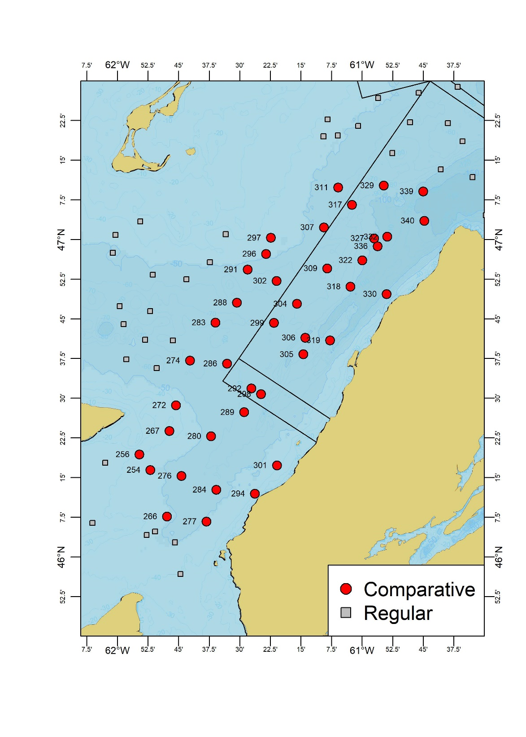

**Figure 1** : Spatial distribution of the 40 comparative survey stations (red circles) along with their station identification numbers. Regular 2019 survey stations are shown as grey squares.

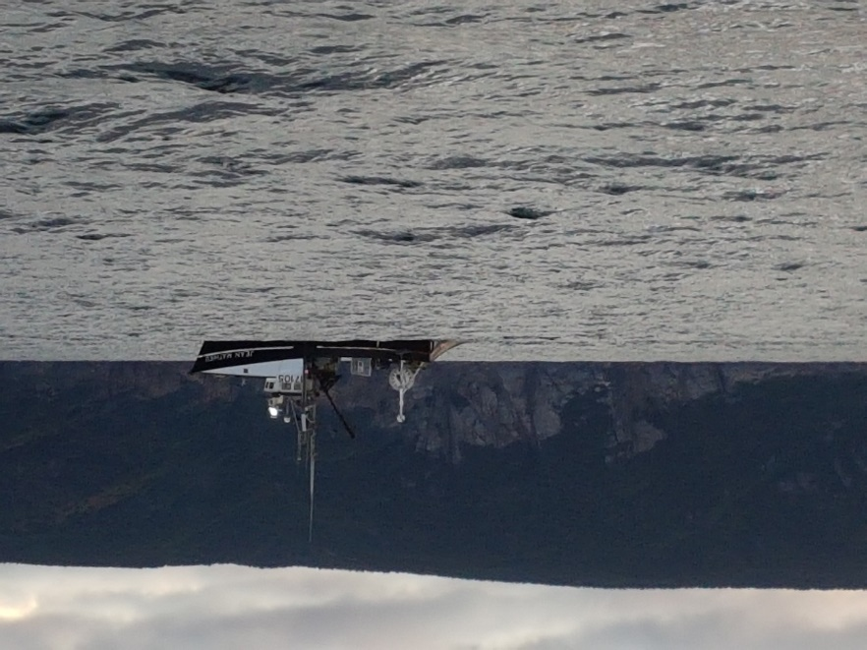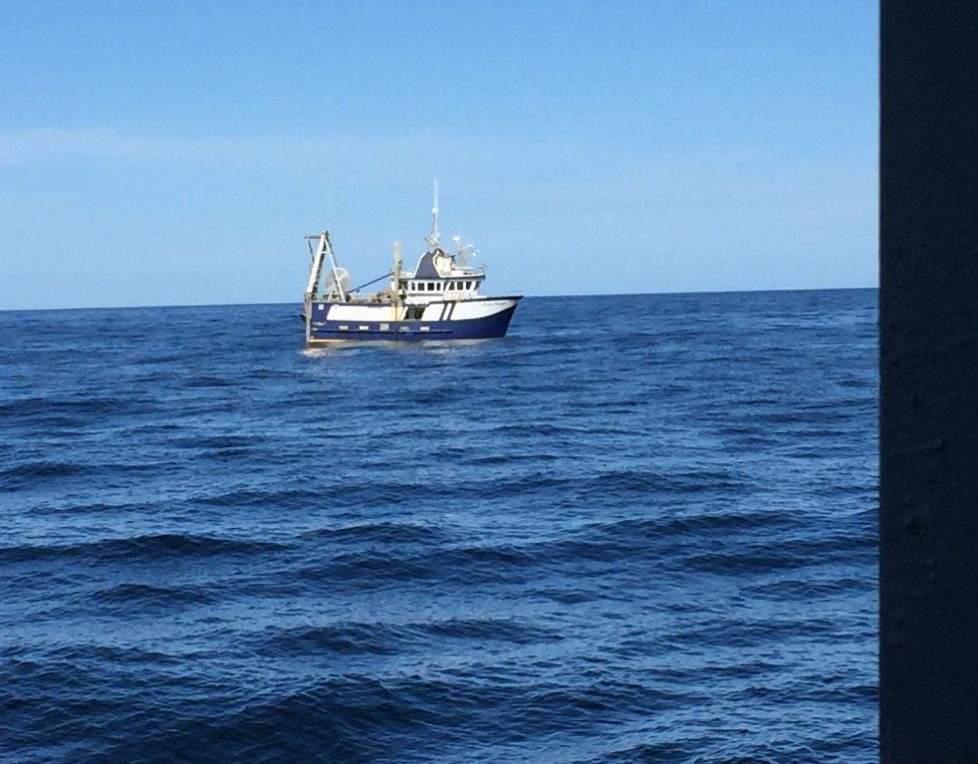

**Figure 2**: Comparative survey vessels, the Jean Mathieu (left) and the Avalon Voyager II (right).

eSonar probe

Star-Oddi

Minilog TD

Star-Oddi Tilt

Headline

Footrope

Cod end

Wing

Bridle

Door

Wing

Depth

Height

Wing

Floaters

**Figure 3** : Schematic view of the various sensors deployed for the 2017 snow crab bottom trawl survey. eSonar acoustic net sensors (a pair of distance sensors and height sensor), Star-Oddi temperature/depth and temperature/depth/tilt probes, and a Vemco Minilog temperature/depth sensor.

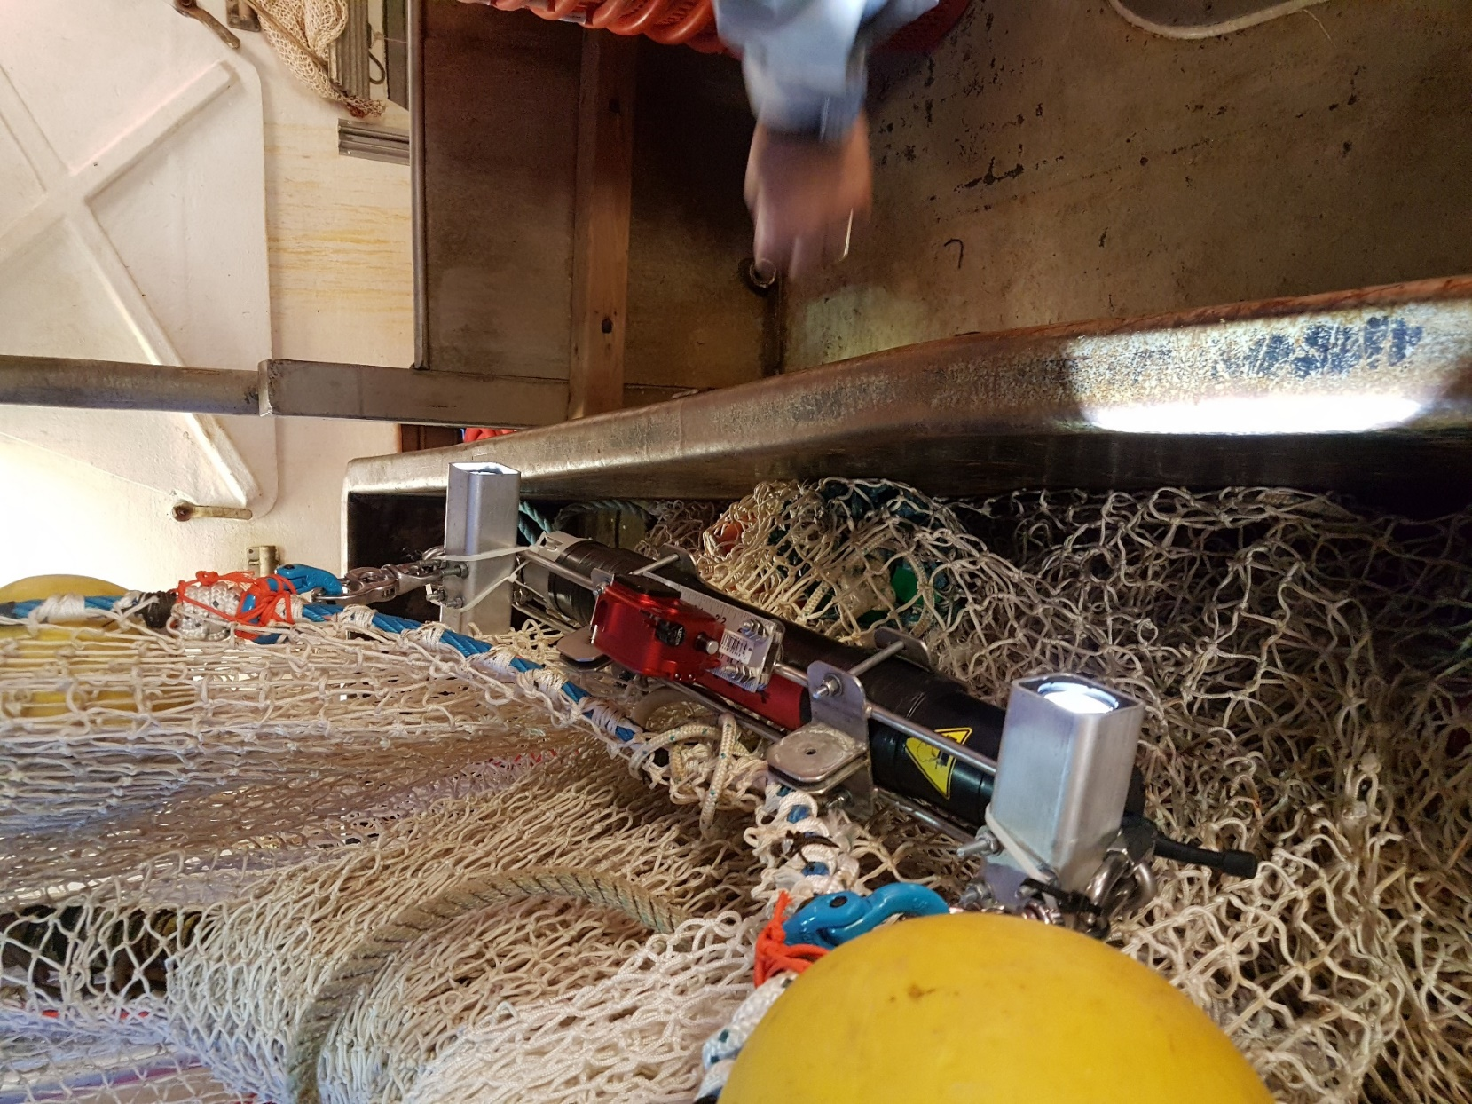

**Light**

**Light**

**GoPro Camera**

**Flowmeter**

**Figure 4**: Set-up used for the Aquadopp 300 flowmeter and the GoPro camera, attched to the trawl head line.



Winches

activated

Door

touchdown

**Figure 5** : Trawl depth profile of a typical Snow Crab Survey tow, showing the names of the various phases and significant events referred to in the text.



**Figure 6**: Spatial distribution of comparative vessel (Jean Mathieu, grey tracks) trawl tracks relative to those of the new survey vessel (Avalon Voyager II, red tracks), centered to a single point and aligned. Survey tracks with grey points indicate stations sampled by the regular survey captain (GB).

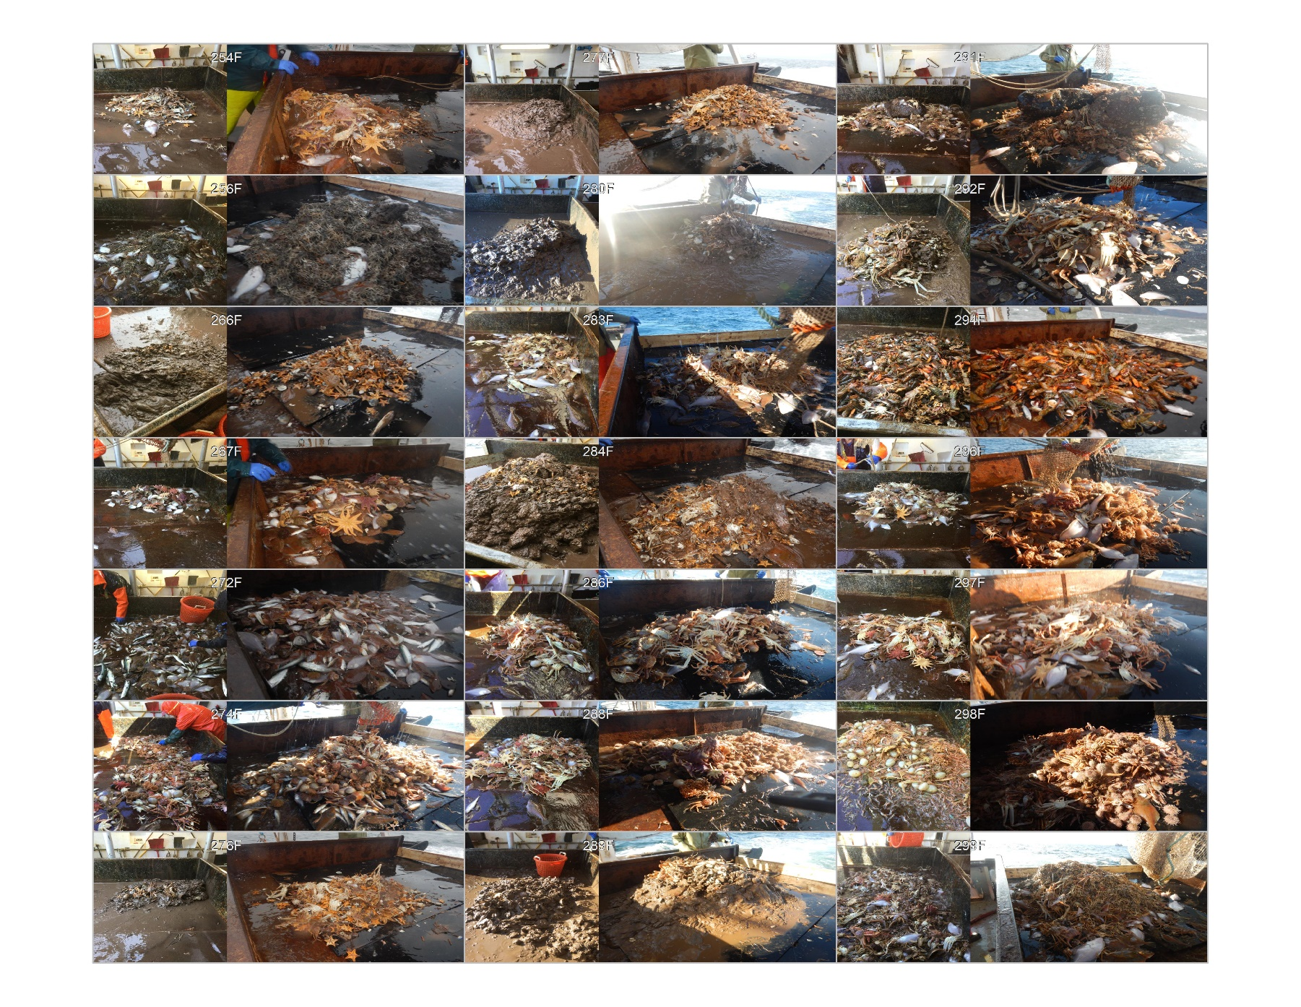**Figure 7a** : Photos of comparative tow catches from the Avalon Voyager II (left-hand phtos) and the Jean Mathieu (right-hand photos). Tow IDs on the tow of each catch pairs identify the sampling stations.

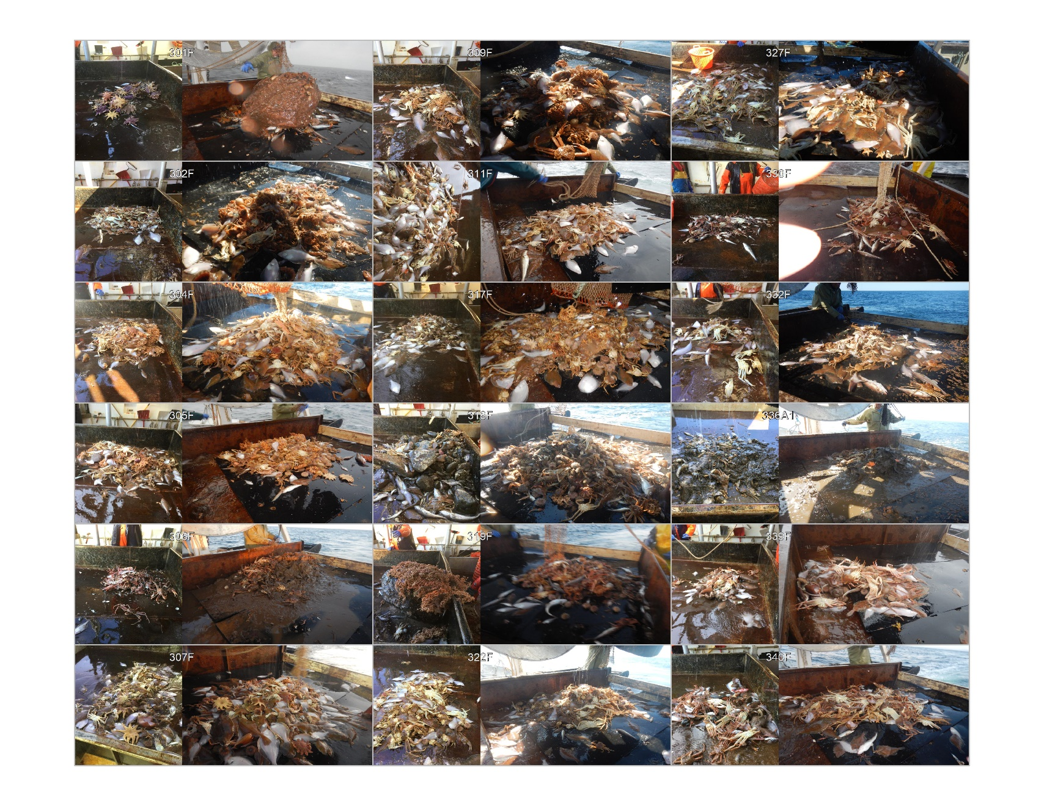

**Figure 7b** : Photos of comparative tow catches from the Avalon Voyager II (left-hand photos) and the Jean Mathieu (right-hand photos). Tow IDs on the tow of each catch pairs identify the sampling stations.

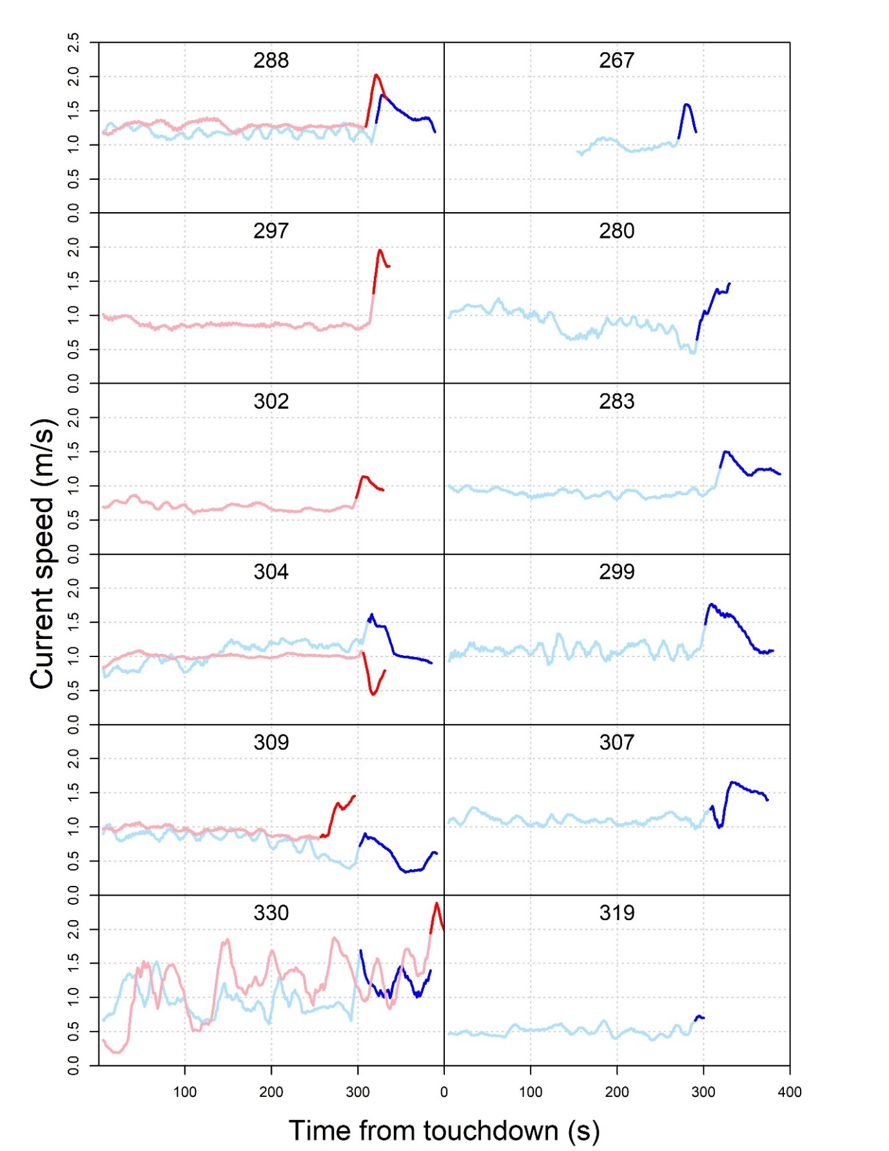

Figure 8 : Flowmeter current flow rates during the active (light shades) and passive (darker shades) trawling phases for the Avalon Voyager II (blues lines) and Jean Mathieu (red lines). Numbers indicate the station identification number.

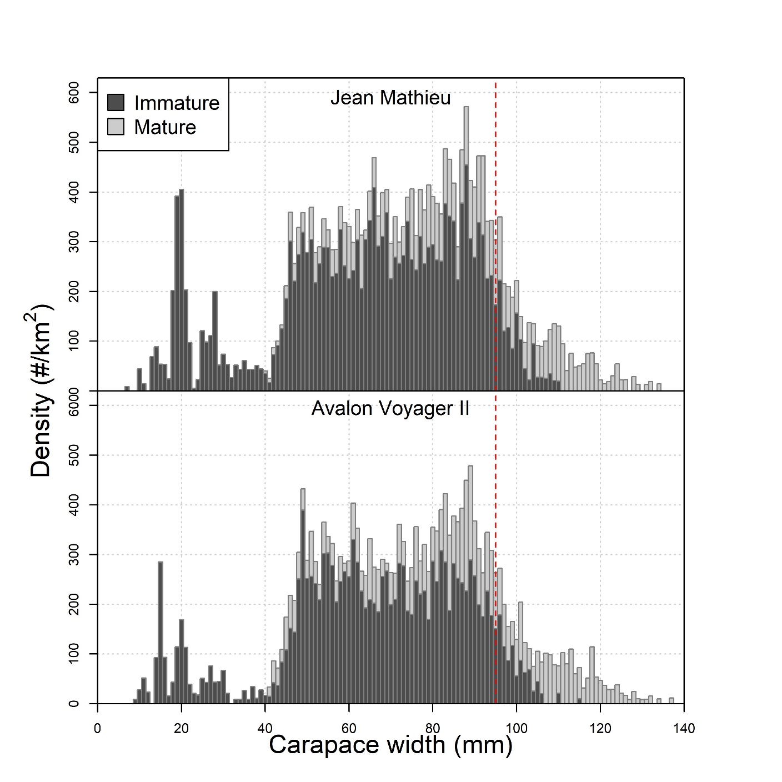

Figure 9 : Average density by carapace width of male snow crab in the comparative survey catches, by maturity stage.

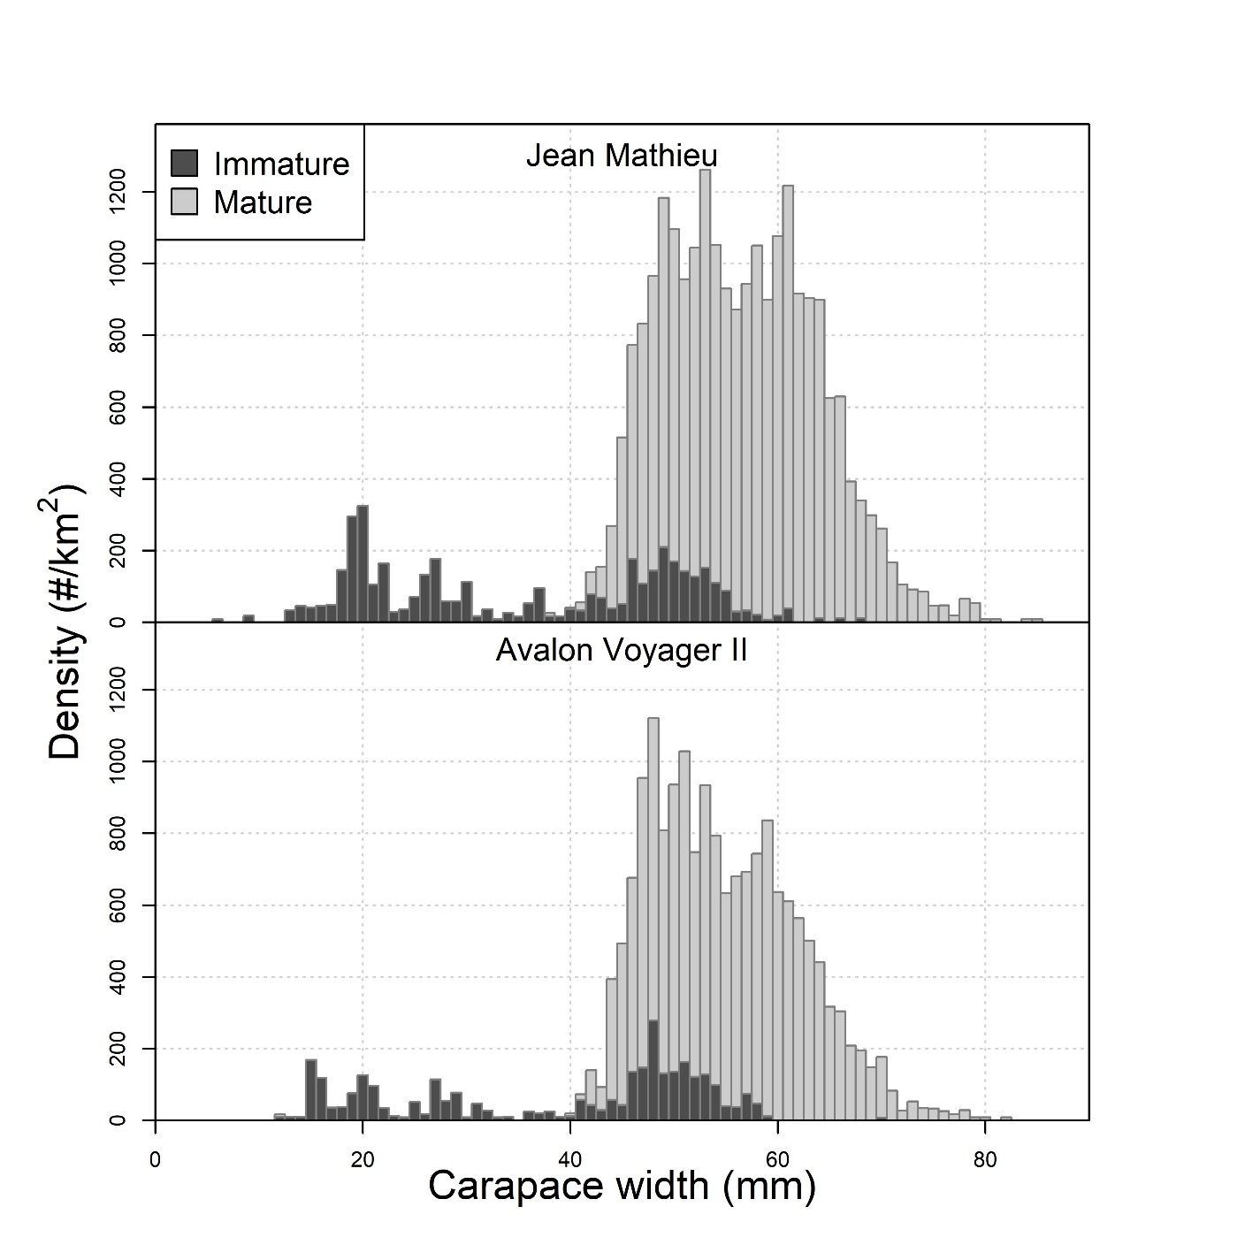

Figure 10: Average density by carapace width of female snow crab in the comparative survey catches, by maturity stage.

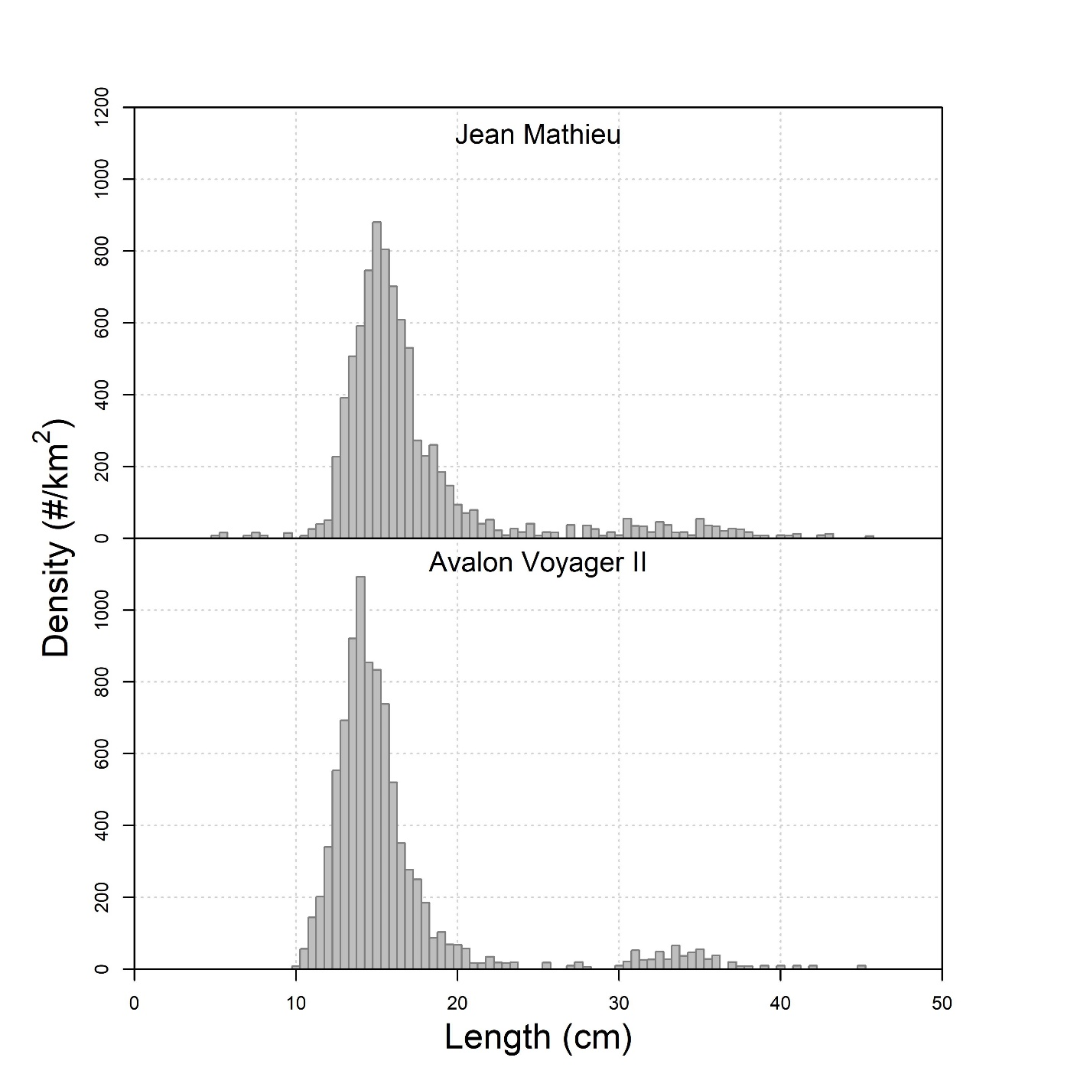

Figure 11 : Average density by fish length of Atlantic cod (*Gadus morhua*) in the comparative survey catches.

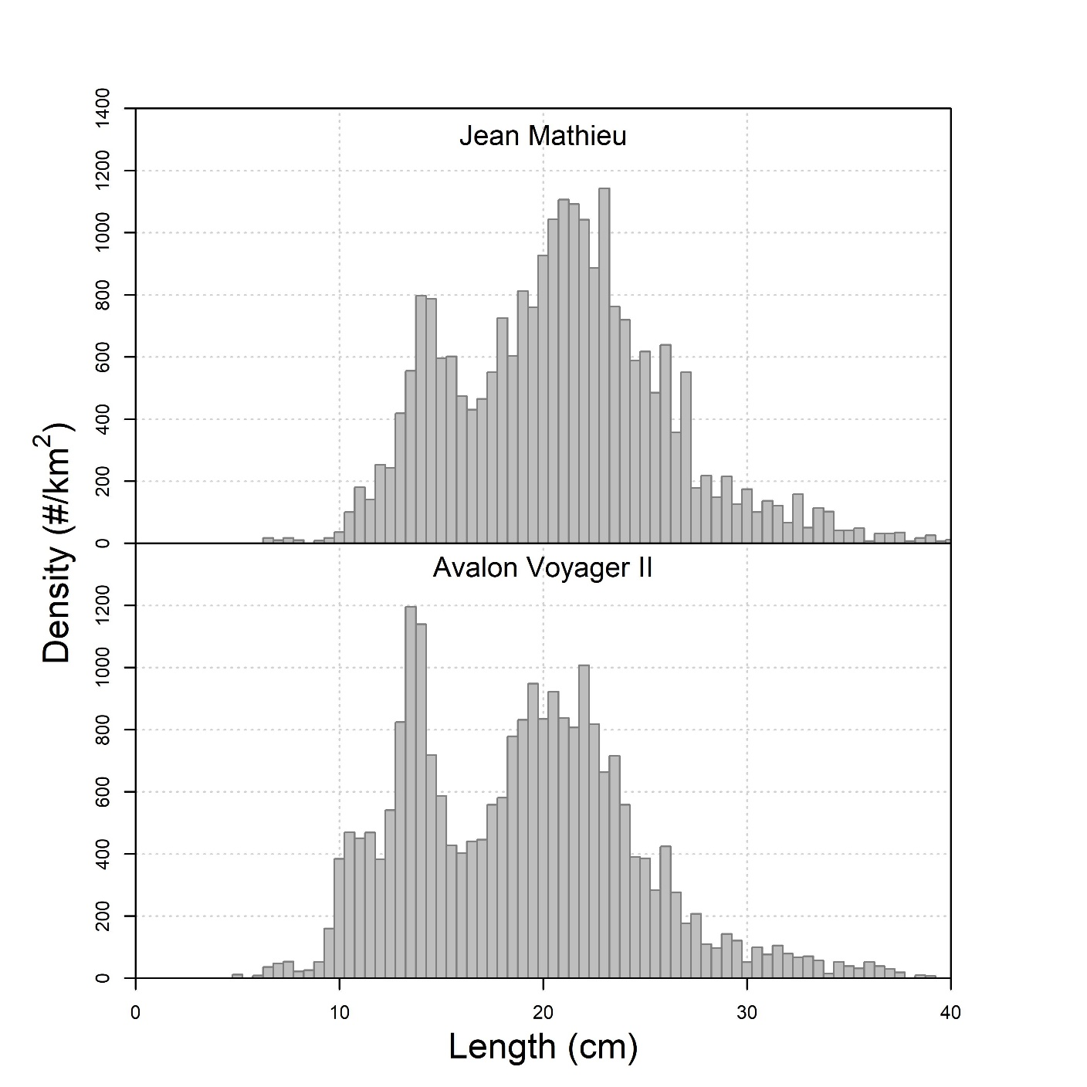

Figure 12 : Average density by fish length of American plaice (*Hippoglossoides platessoides*) in the comparative survey catches.

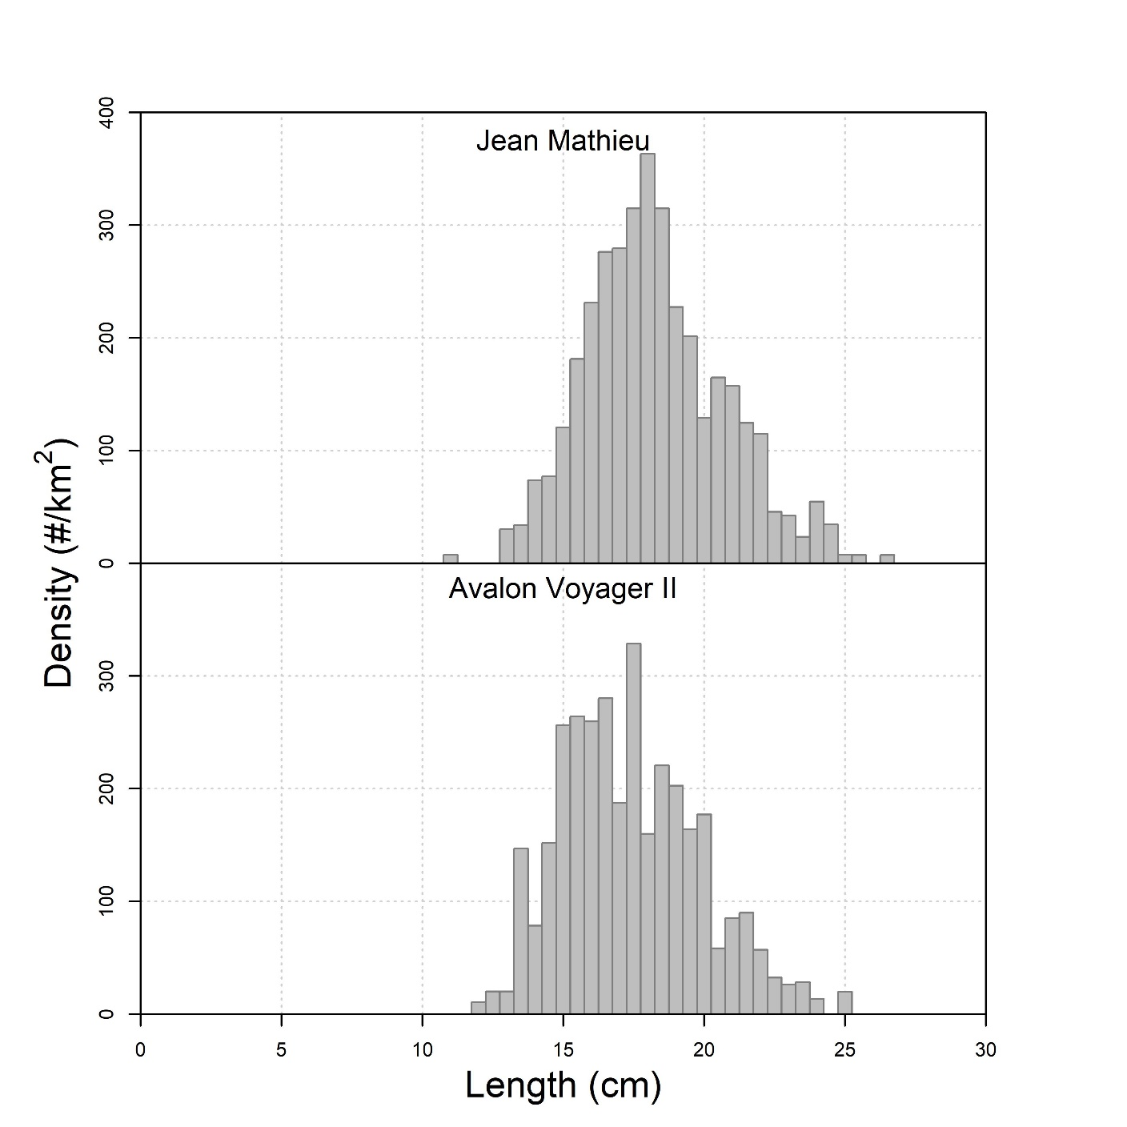

Figure 13 : Average density by fish length of Yellowtail flounder (*Limanda ferruginea*) in the comparative survey catches.



**Figure 14**: Vessel effect boxplots showing the 95% credibility intervals (whiskers), the interquartile range (box) and median values from the Bayesian catch analysis for snow crab groups, three fish species and six benthic invertebrate species.

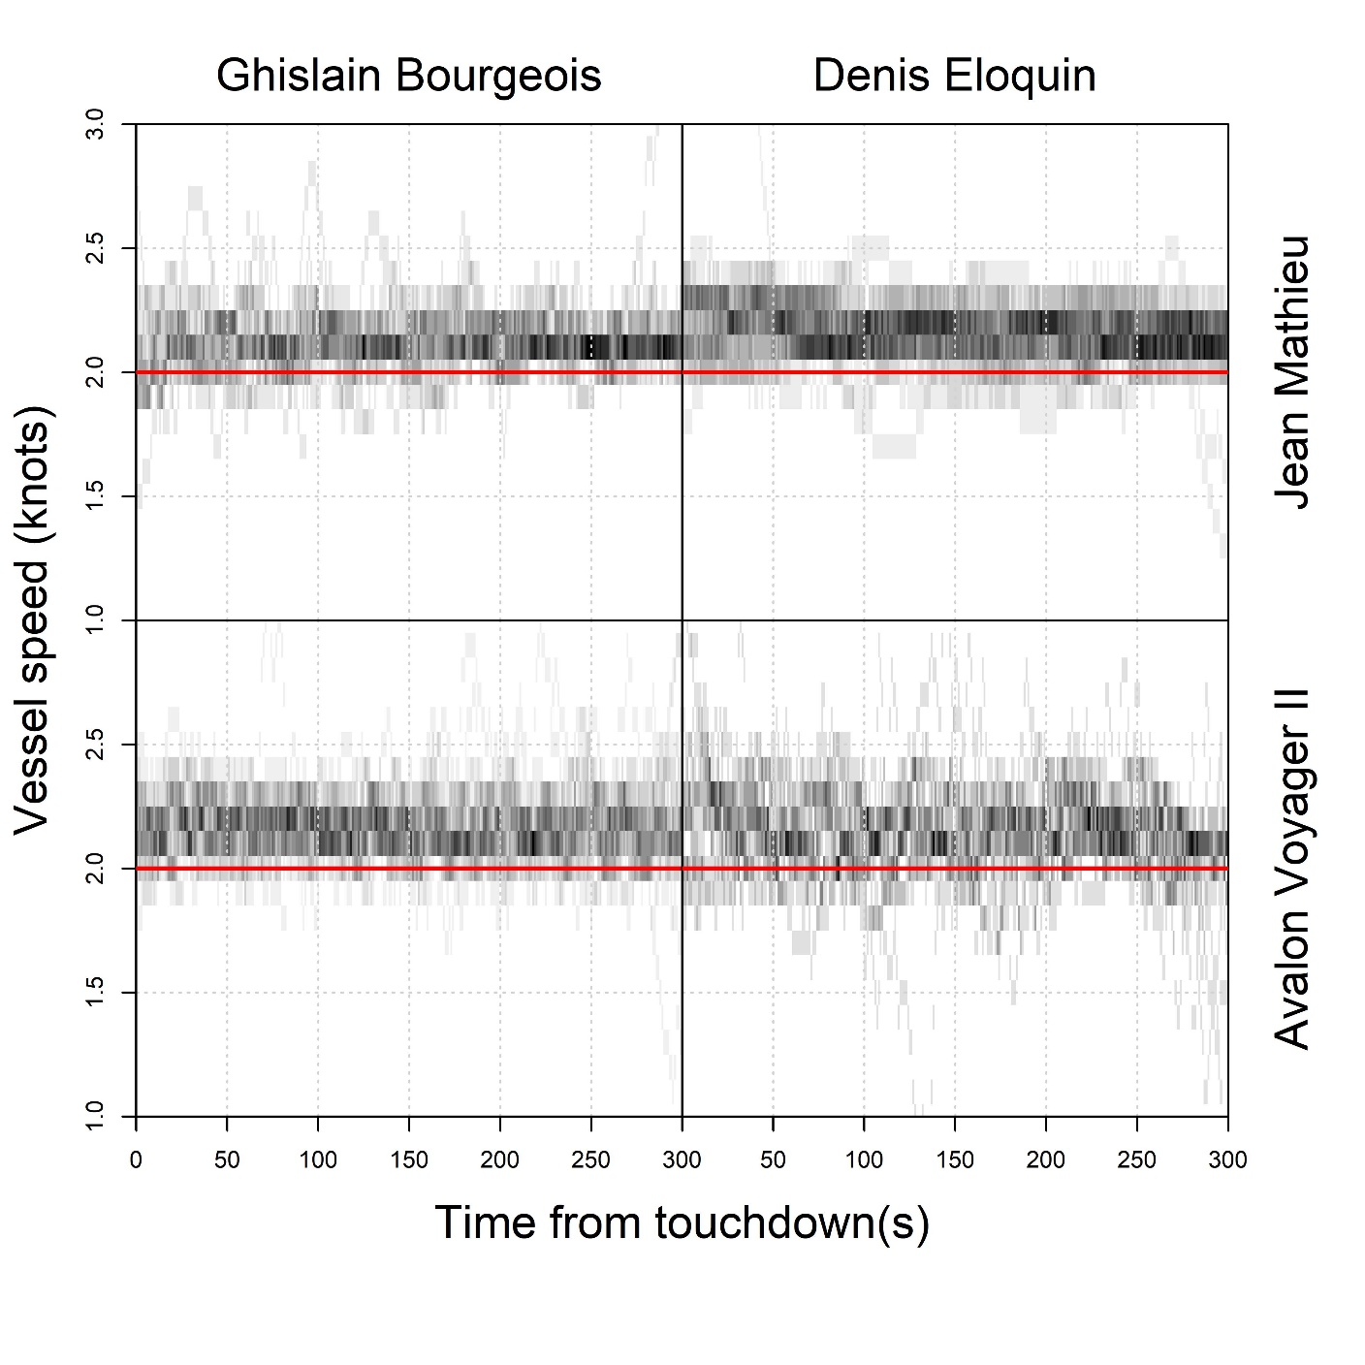

**Figure 15** : Overlay plot of survey vessel speeds during active trawling profiles by survey vessel and captain.

* Figure X shows an overlay plot of the speed profiles of the survey vessel during active trawling for each combination of survey vessel and captain. These profiles show that the captains generally target speeds of 2.1-2.2 knots, presumably to avoid falling below the 2 knot limit as set per the protocol.
* There is a higher degree of variability on board the Avalon Voyager II, most notably under captain Eloquin. This variability is in part due to lack of a variable-pitch control on the Avalon, which makes it more difficult to maintain a fixed speed during trawl. Weather is also a contributing factor, sometimes leading to periodic undulations in the vessel’s speed.

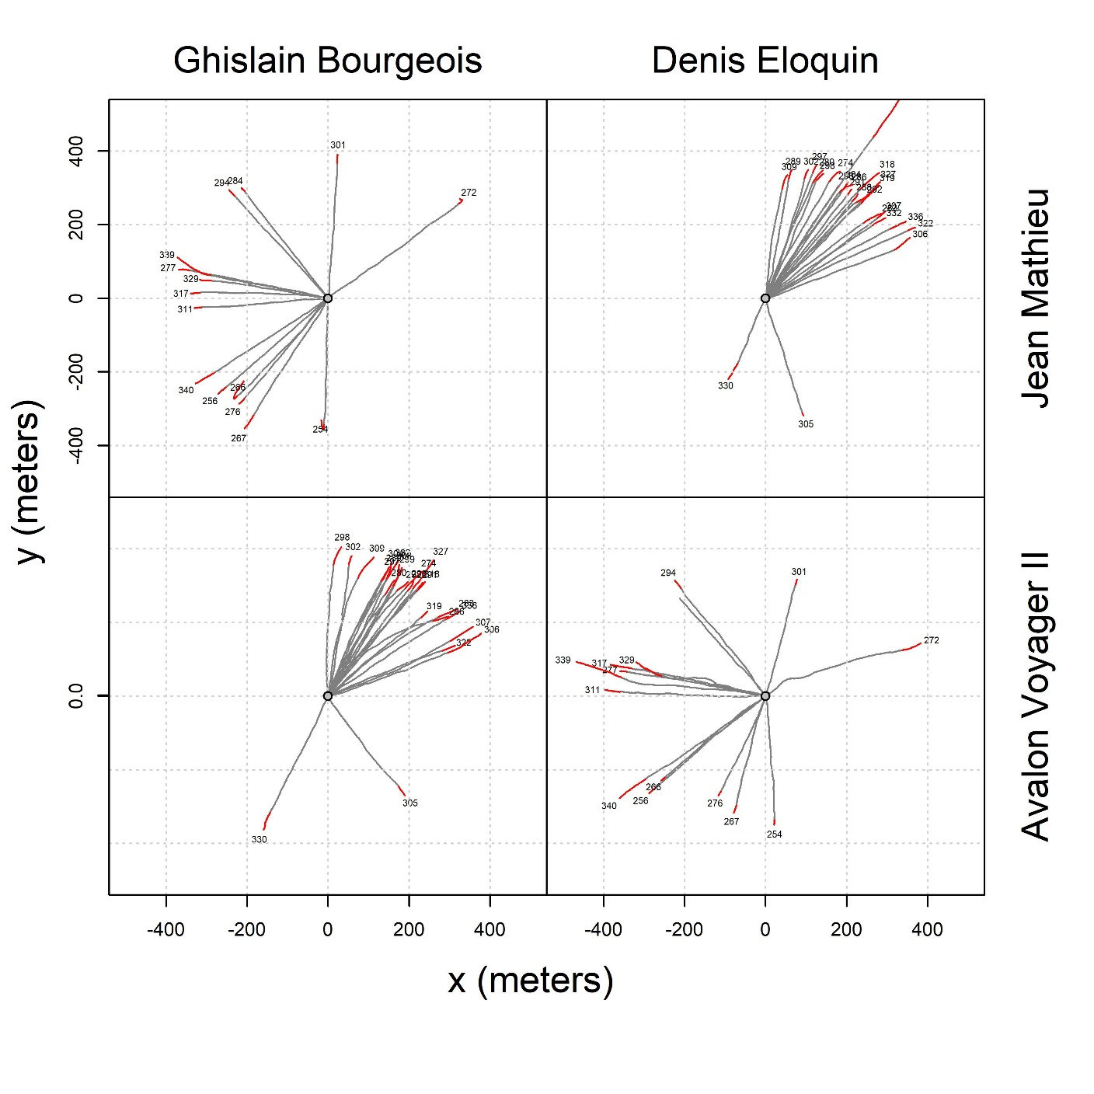

Figure 16 : Vessel tracks by vessel and captain. The center point marks the start of each tow. The grey portion shows the movement of the vessel during the active trawling phase while the red portion marks the vessel movement during the passive phase, prior to liftoff.

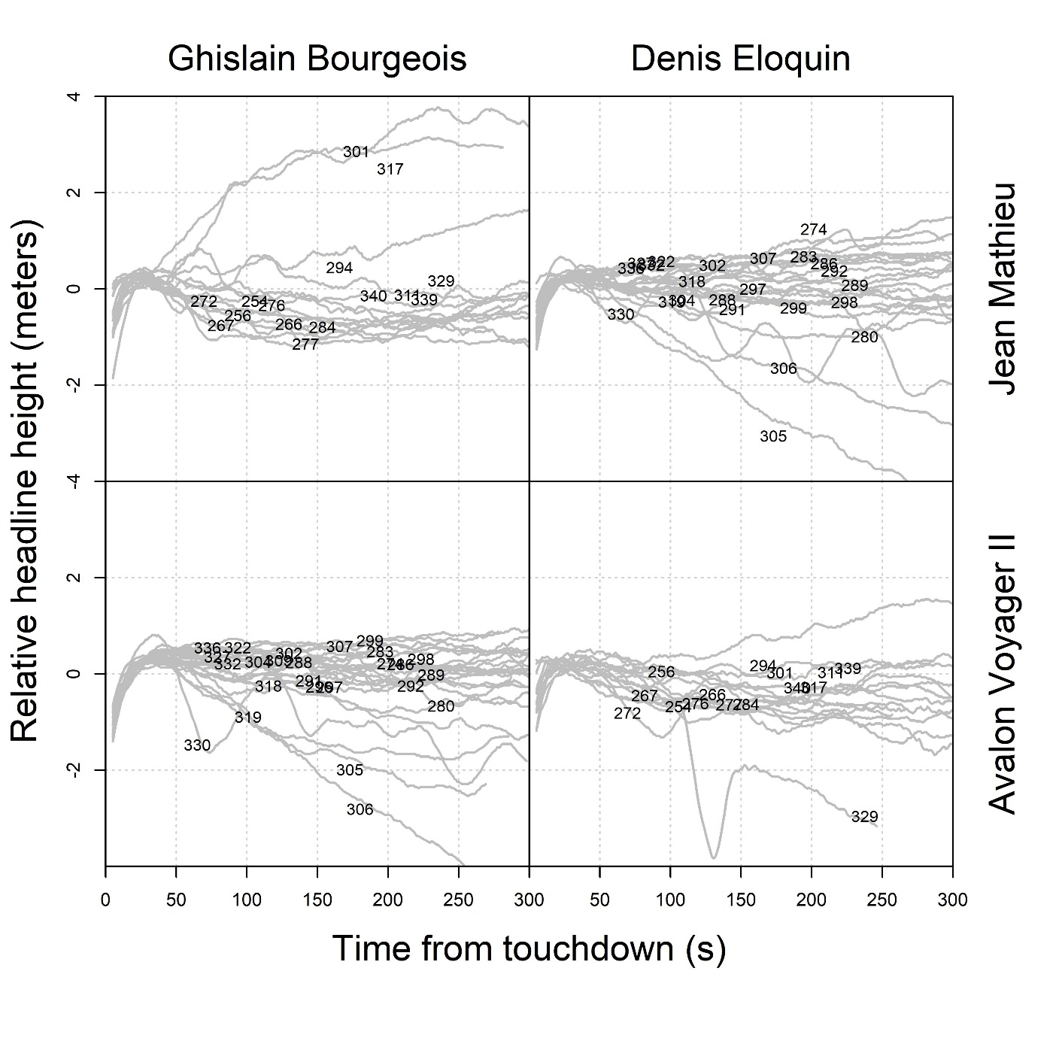

Figure 17 : Headline variation by vessel and captain (moving average 10-second window)

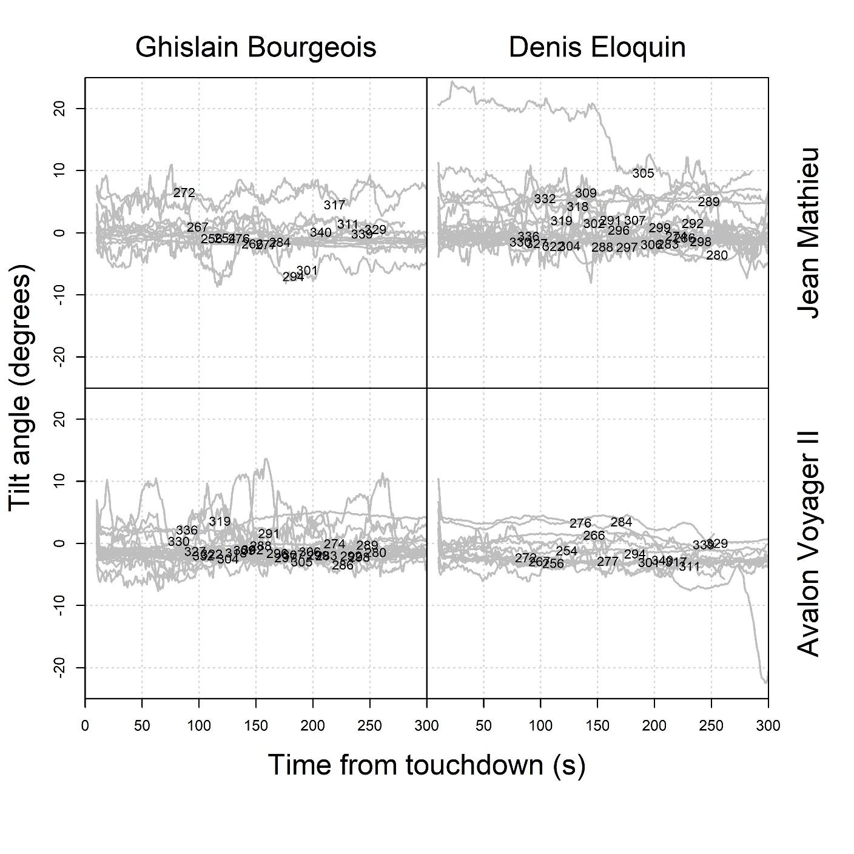

Figure 18 : Tilt mechanism by vessel and captain

**APPENDIX A : TOUCHDOWN AND LIFTOFF ESTIMATION**

* Present tilt analysis model

**APPENDIX B : SWEPT AREA ESTIMATION**

* Present swept area analysis of wingspread data

**APPENDIX C : PASSIVE PHASE SWEPT AREA**

If the survey vessel maintains its heading during the passive phase, the vessel’s contribution to the trawl movement $l_{v}$ is given by $l_{v}=v_{p}×t_{p}$, where $v_{p}$ is the vessel’s average speed during the passive phase and $t_{p}$ is its duration. The winch’s contribution to the trawl movement is given by:

$$l_{w}=\sqrt{c_{0}^{2}-d^{2}}-\sqrt{{\left(c_{0}-{v_{w}×t}_{p}\right)}^{2}-d^{2}}$$

where $v_{w}$ is the winch speed, $d$ is the water depth, $c_{0}$ is the initial warp cable length used during regular trawling (i.e. $c_{0}≈3d$). Thus, the total swept area of the passive phase for a given tow can be calculated as $s_{p}=w_{p}×(l_{v}+l_{w})$, where $w_{p}$ is the average trawl wing spread during the passive phase. The liftoff angle between the trawl cables and the sea bottom are given by $ϕ=\arcsin\left(\frac{d}{c_{0}-{v_{w}t}_{p}}\right)$. For a 3:1 warp ratio, $ϕ≈{20}^{o}$ during regular trawling up to the beginning of the passive phase. As the trawl approaches the vessel, $ϕ$ will increase up to some value until the trawl finally lifts off the bottom.

Vessel

Door at stop

position

$$d$$

$$ϕ≈19.5°$$

$$ϕ$$

Door at liftoff

position

$$l_{w}$$

Depth

$$c_{0}-{v_{w}×t}_{p}$$

Warp length at stop position

Door movement

$$c_{0}$$

Warp length at liftoff

**Figure X** : Trigonometric diagram of the distance travelled by the trawl due to winch action.

**Table X**: Description of passive phase input parameters and their data sources.

|  |  |  |
| --- | --- | --- |
| **Parameter** | **Description** | **Source** |
| $$t_{p}$$ | Passive phase duration | Analysis of Star Oddi tilt probe data. |
| $$v_{p}$$ | Vessel speed | Vessel GPS. |
| $$c_{0}$$ | Warp length | Counting off 25 fathom cable length markers by captain. |
| $$v_{w}$$ | Winch speed | Trawl door haul time divided by warp length. |
| $$d$$ | Water depth | Water depth according to ship sonar. |
| $$w_{p}$$ | Trawl width | eSonar wing spread observations. |

**Uncertainties:**

Calculation of passive swept areas rely on a fair number of assumptions which may leave it vulnerable to estimation bias:

1. The warp cables likely sag under their own weight, so the trawl may be somewhat closer to the vessel than the trigonometric model assumes.
2. The liftoff times, because lifting the trawl off the bottom is a more protracted process than the touchdown, are more difficult to estimate. In particular, the effective degree of contact of the footrope during the liftoff process is unknown.
3. The configuration of the trawl may be less than optimal during this phase. For instance, asymmetry in the length of the warp cables during winching could lead to a lower effective wing spread, thus swept area would be lower than estimated.
4. Fourthly, trawling speed is generally faster and more variable during the passive trawling phase than in the active trawling phase, which could lead to differences in catchability between the two phases.
5. If the vessel deviates from its heading during the passive phase, the movement of the trawl will also be somewhat reduced.
6. Trawl winch speed is average value, estimated from the total warp length divided by the time it takes to haul the doors to the surface. This estimate does not account for any variations in the winch speed which may have occurred.

**APPENDIX D : Catch Analysis MultiBUGS Program**

model{

# Simulate swept area variables:

for (i in 1:n_station){

for (j in 1:n_vessel){

# Swept area during active trawling:

tau_area[i,j] <- pow(area_sigma[i,j], -2)

tmp[i,j] ~ dnorm(area_mu[i,j], tau_area[i,j]) I(0, )

area[i,j] <- cut(tmp[i,j])

# Swept area for passive trawling:

area_passive[i,j] <- area_passive_mu[i,j]

}

}

# Station-level effects priors:

tau_station ~ dgamma(0.001, 0.001)

sigma_station <- pow(tau_station, -0.5)

for (i in 1:n_station){

station_effect[i] ~ dnorm(0, tau_station)

}

# Vessel effects:

vessel_effect ~ dnorm(0, 0.001)

# Boulder effect:

boulder_effect ~ dnorm(0, 0.001)

# Gamma shape parameter:

r ~ dunif(0, 1000)

# Logit-scale intercept:

alpha ~ dnorm(0, 0.001)

# Define log-scale mean:

for (i in 1:n_station){

for (j in 1:n_vessel){

log(mu[i,j]) <- alpha +

(j-1) * (vessel_effect) +

station_effect[i] +

boulder_effect * boulder[i,j] +

log(area[i,j] + area_passive[i,j])

# Gamma rate parameter:

m[i,j] <- r / mu[i,j]

# Gamma-Poisson likelihood:

lambda[i,j] ~ dgamma(r, m[i,j])

}

}

# Conditional Poisson likelihood:

for (i in 1:n_station){

for (j in 1:n_vessel){

z[i,j] ~ dpois(lambda[i,j])

}

}